Rules and Regulations (continued)
7. Two cremains are permitted per grave
site. One cremains is permitted on top
of a full burial vault. The practice of
scattering cremains is not allowed by the
teachings of the Roman Catholic Church.

8. Grave decorations are permitted from
the Thursday before Memorial Day until
the last Sunday of June. At all other
times, particularly during the mowing
season (April 1 – November 1) the only
decorations permitted will be those
attached to the tombstone or in vases
that are embedded in the foundation.
The Cemetery staff will pick up and
dispose of those decorations that remain
on the graves after the allowed time.
There are to be no plantings or digging
of holes in the ground

9. The original purchaser, or his or her
representative, is responsible for
monument maintenance. It is agreed
and understood that Saint Mary Catholic
Church is not to be held responsible for
acts of vandalism or malicious mischief
committed against monuments or
markers beyond the exercise of
reasonable vigilance and supervision.

10. All purchasers of Interment Rights are
expected to observe all the above rules
and regulations. The Board of Directors
of Saint Mary Catholic Church reserves
the right to make any additional
regulations or changes in same for the
betterment of this Cemetery.

Updated 11 June 2014

_______________________________________________________________________________________

Saint Mary Catholic Church Cemetery
Solon, Iowa

Certificate of Interment Rights

_______________________________________________________________________________________

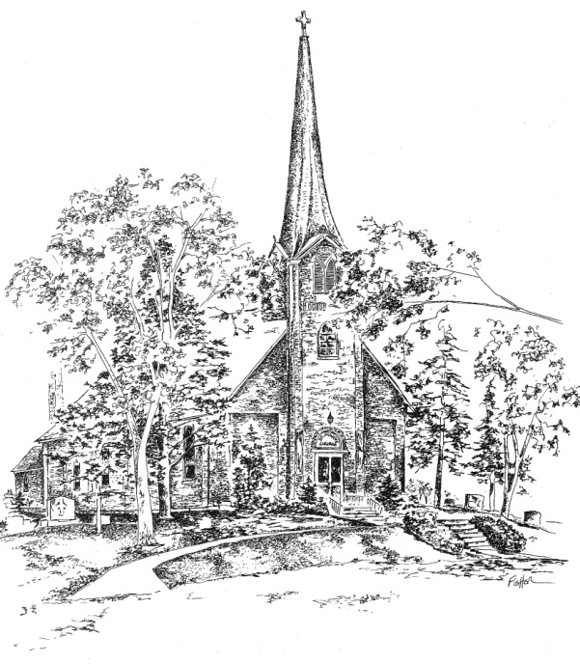

Rules and Regulations

- Interment Rights means the right to use a lot or part of a lot, as purchased from Saint Mary Catholic Church, for the consideration for burial purposes only and under the rules and regulations prescribed by the Board of Directors of said Saint Mary Catholic Church for such use.

- The Certificate of Interment Rights to a cemetery lot invests in the purchaser the right to use such lot for burial purposes only for the person(s) named on the Certificate. Should the purchaser wish to transfer the Certificate to another family member, a new Certificate of Interment Rights must be issued by Saint Mary Catholic Church. This is to ensure accurate record-keeping for the Cemetery.

- Purchaser cannot re-sell their lots to any person or persons whomsoever. However, lots that are unused may be sold back to Saint Mary Catholic Church Cemetery for its purchase price. (NOTE: If a monument has been placed on a lot, and the purchaser wishes to sell the unused lot back to the Church, it is the responsibility of the original purchaser to remove the monument and footing and return the lot to its original condition before it is sold back to the Church).

- Cemetery Lot is defined as two burial spaces.

- Disinterments will be made in the Cemetery only with the permission of the pastor and according to the requirements of the Statutes of the State of Iowa and the rules of the State Board of Health.

- A concrete vault is required for ALL burial interments.

Certificate of Interment Rights

Saint Mary Catholic Church Cemetery, Solon, Iowa

Received from:__________________________________________________________

Interment spaces for:_____________________________________________________
(North interment space)

And:_____________________________________________________
(South interment space)

the sum of _________________________________Dollars; Check #:_____________

In Section ______________; for Lot Number _____ between markers _____ & ______.

The above premises to be used only as a place of burial for the dead, and subject to
the Rules and Regulations, and with the privileges specified in the Regulations of said
Saint Mary Catholic Church Cemetery hereon endorsed and which are made a part of
this contract.

Purchaser’s Signature: ________________________________________________

Purchaser’s Address: ________________________________________________

________________________________________________

Phone:____________________ Date:_________________

Cemetery
Representative Signature: ________________________________________________

Date:_________________

