Welcome to the Diocese of Davenport. You have agreed to be an employee or volunteer in our diocese. We require all our employees and volunteers that have contact with children more than four (4) times a year to complete our Protecting God’s Children program and have a background check. The Protecting God’s Children program is issued through VIRTUS Online www.virtus.org and background checks are issued through Employment Screening Resources (ESR) https://www.hireconfidence.net/Applicants/AgrLogin.aspx?jal_uid=0.

The Safe Environment Coordinator and/or Local Administrator at the school/parish are authorized to view your information to ensure you stay in compliance with diocesan policy.

Please follow the instructions and print screens below to help you register in VIRTUS, conduct your background check and complete the Protecting God’s Children Training Video. These steps need to be completed in full before you begin your employment or volunteering. This is a 3 step process. Please allow enough time with no interruptions in order to complete this successfully. This also depends on your internet connection.

Step 1: To begin go to the website: www.virtus.org

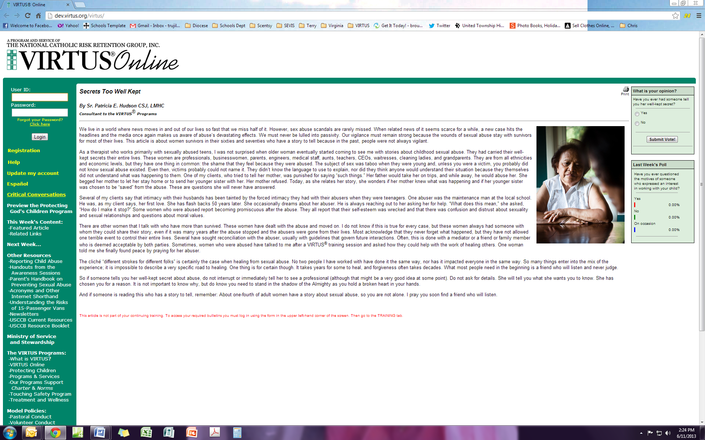
If you need to register in Spanish, click here.
You will click on the “Registration” in yellow on the left of the screen to start the process in English.

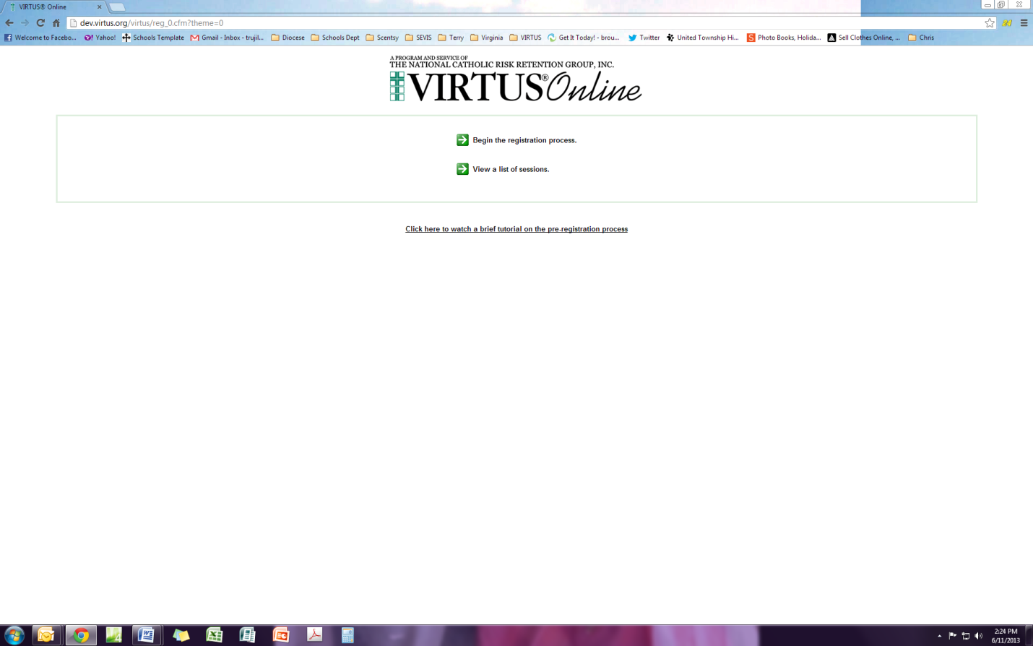
Click on the first green arrow to proceed.

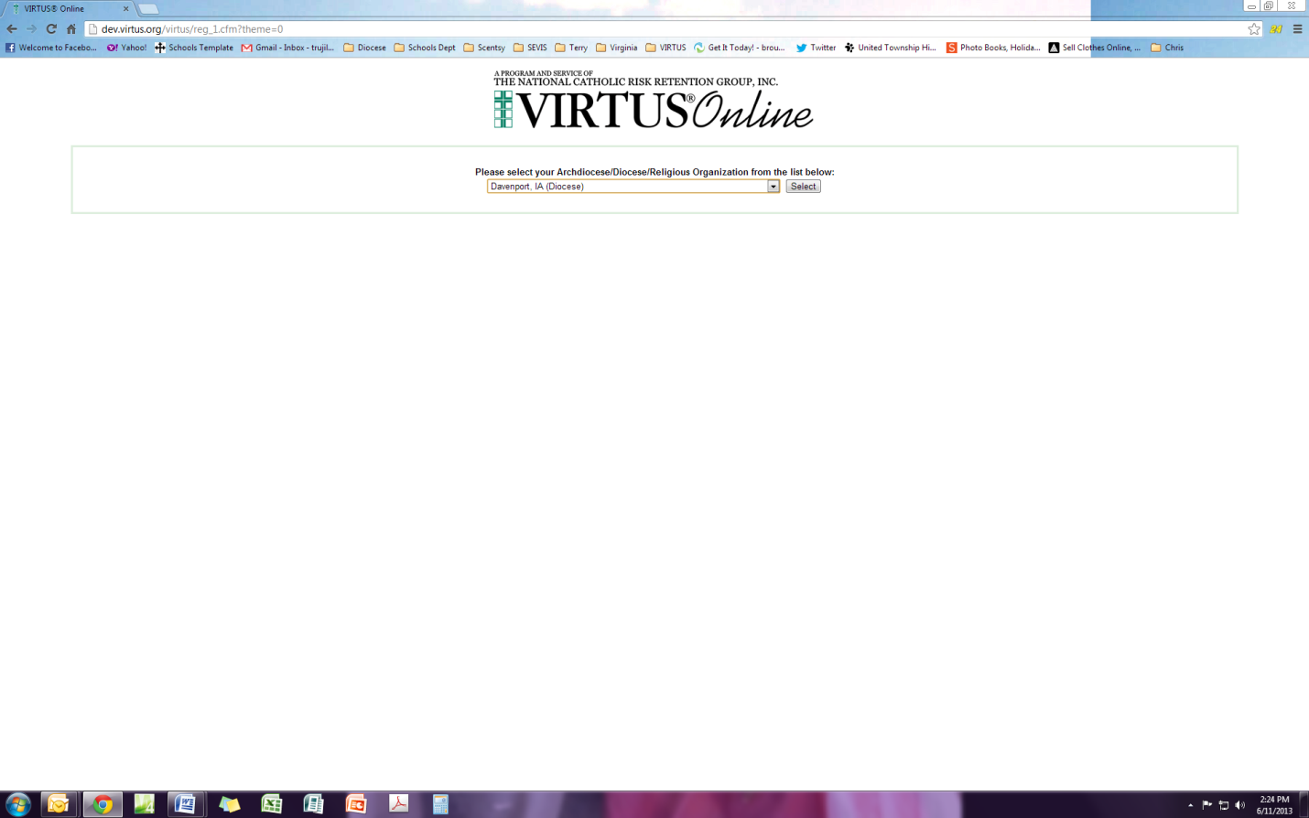
Click on the drop down arrow and select Diocese of Davenport

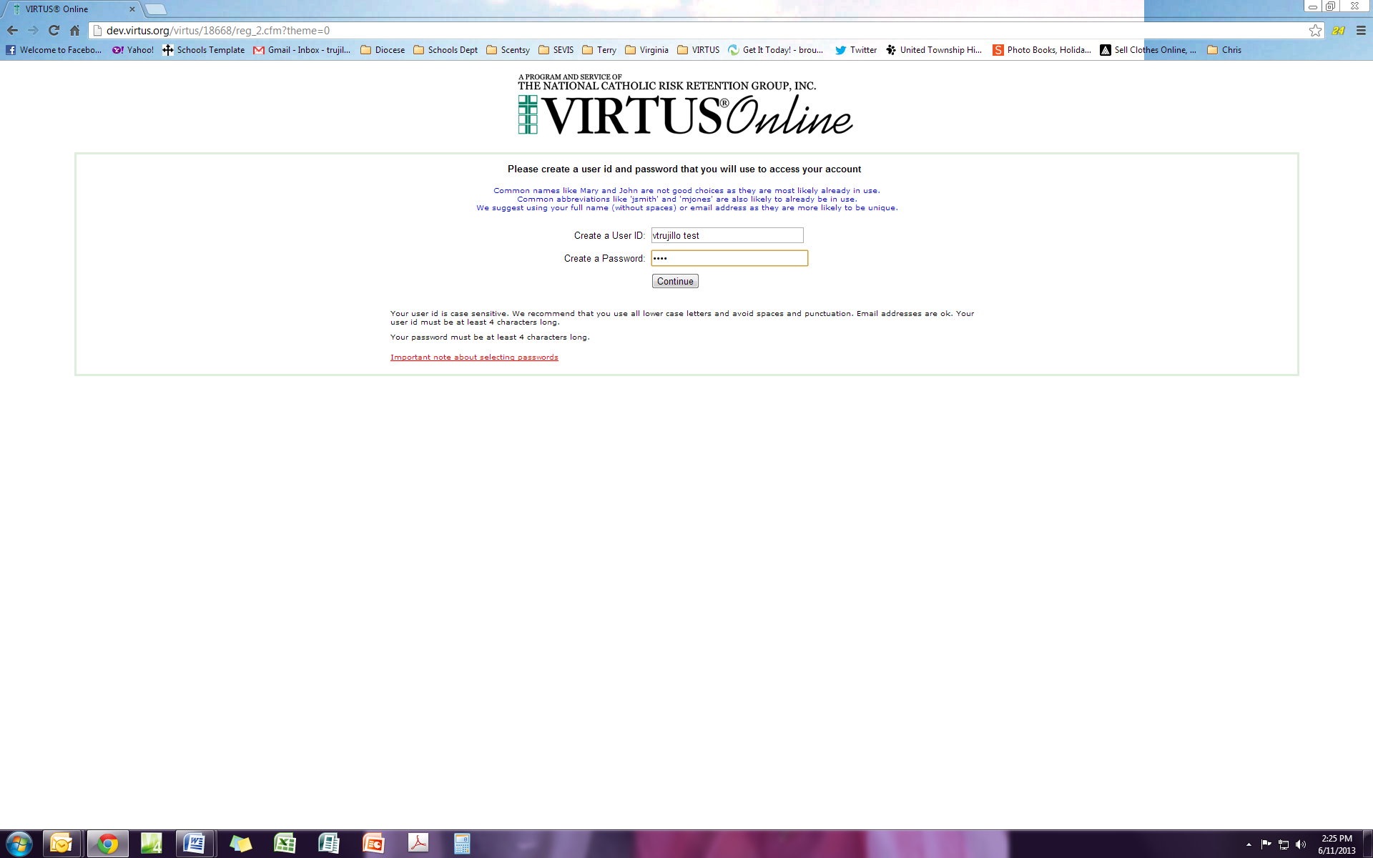
You will need to set up an account for VIRTUS. Please choose a user id and password and write it down somewhere. Password is case sensitive.

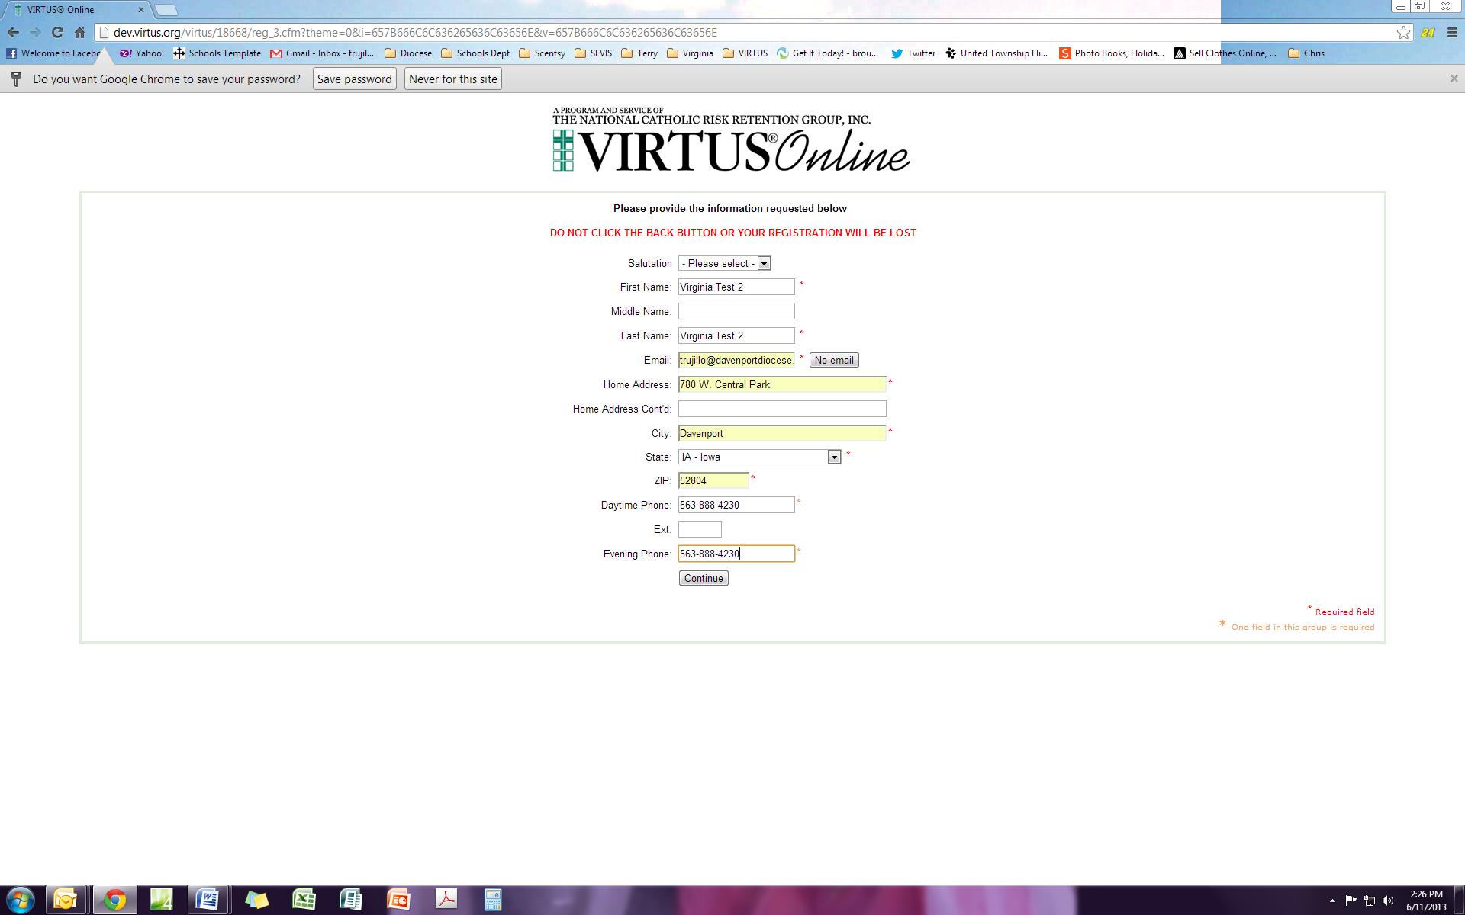
Fill in your current contact information.

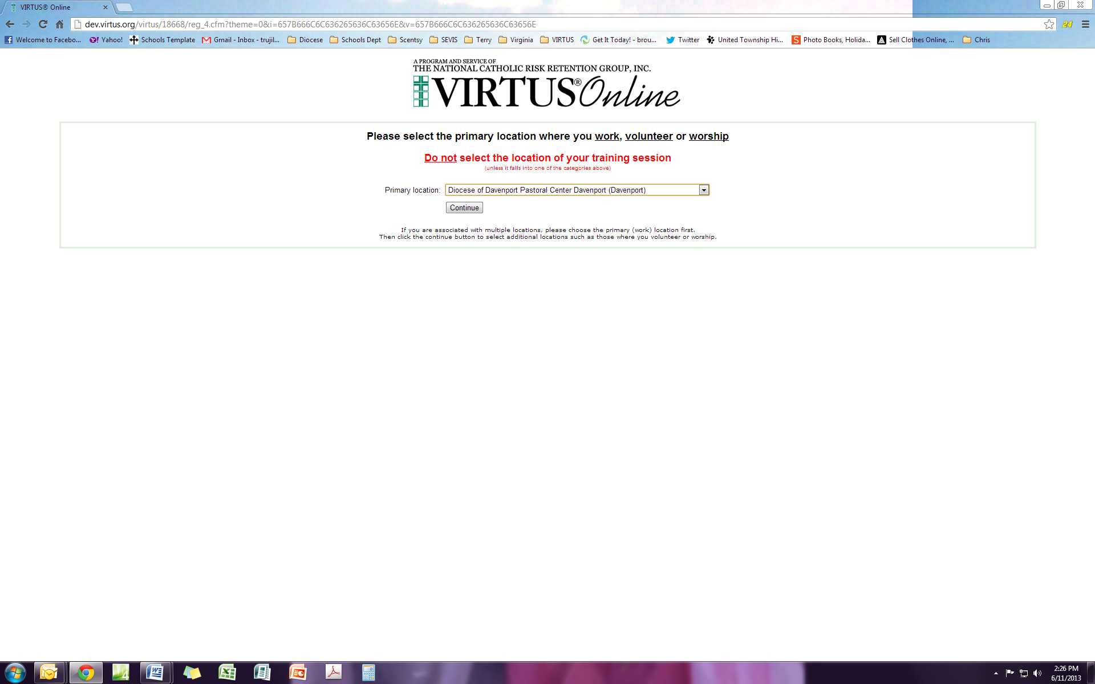
Use the drop down arrow to select the location that is your primary location of employment or volunteering.

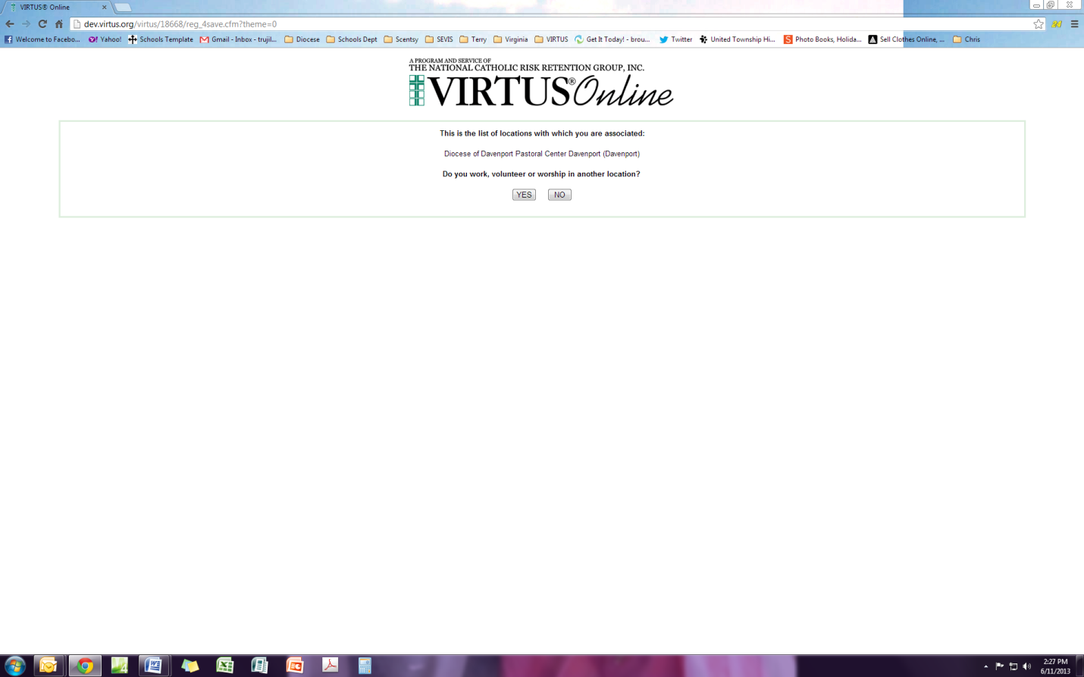
You have an option to choose another location if you are employed or volunteer at another location. If you do not, choose No.

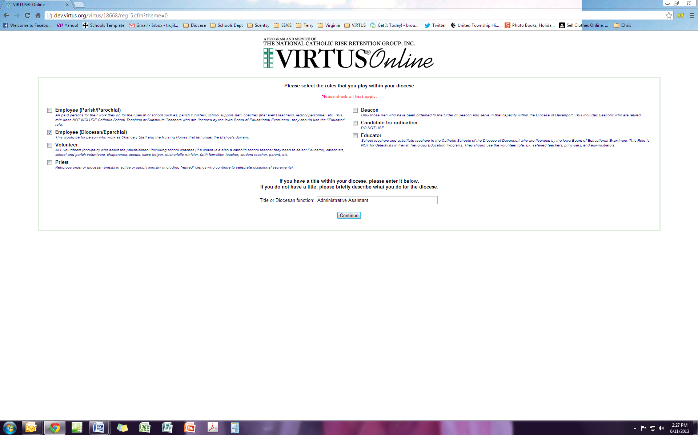
#2
#1
#1 Choose the “Role” that you perform at your primary location. Please read descriptions and choose one. #2 Type your title or function.

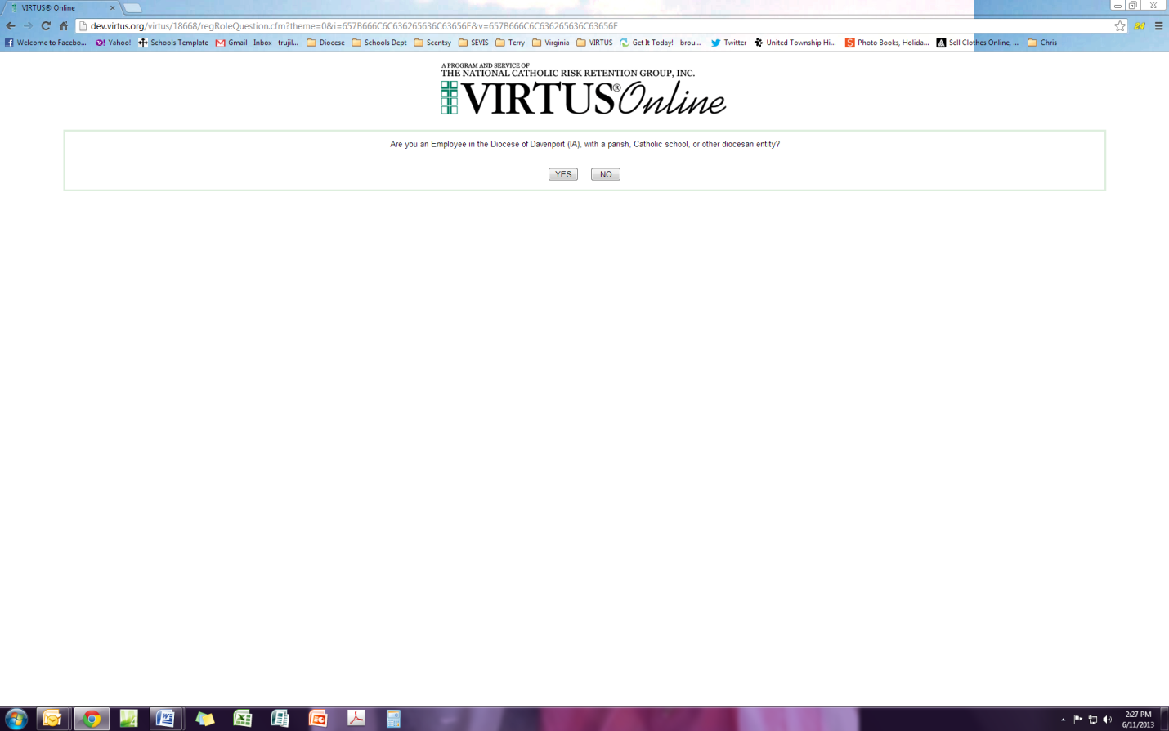
Choose Yes or No

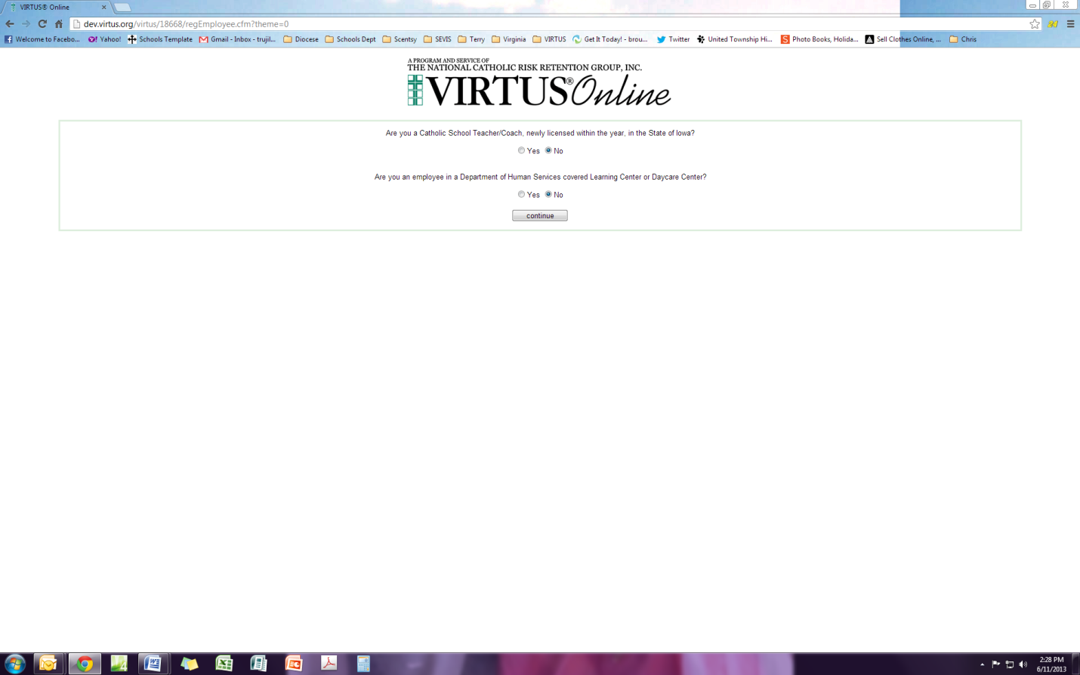
Are you a newly licensed teacher in the state of Iowa or licensed by DHS?

If yes, you will not do a background check via ESR but will be required to send a copy of your license and/or DHS verification to the Diocese of Davenport Attn: CFO, 780 W. Central Park Ave. Davenport, IA 52804.

If you choose No you will go to the ESR website at the end of this registration process.

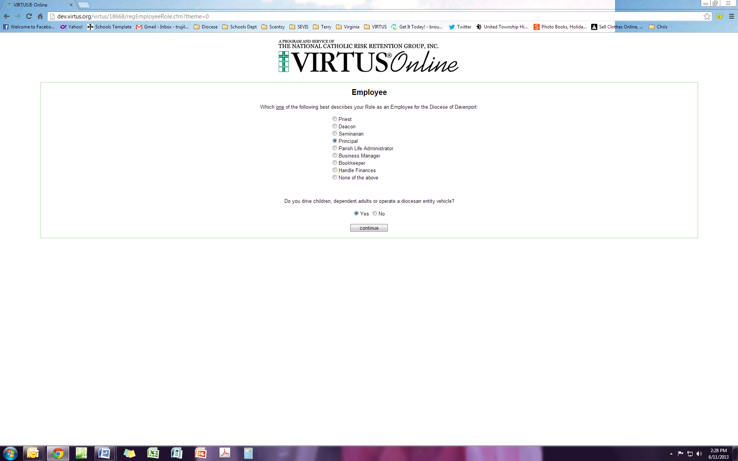
Answer the questions that best reflect your position at the primary location where you are employed or volunteer

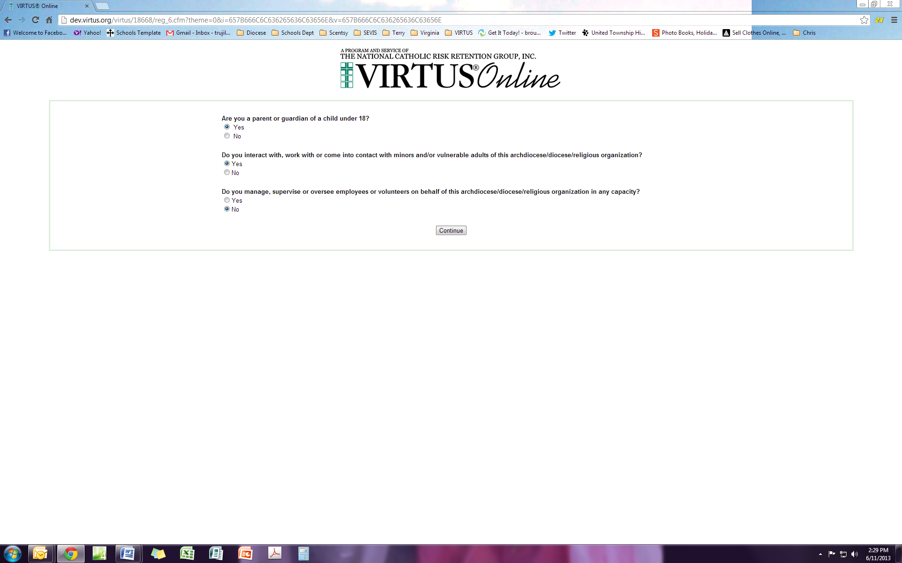
Answer the questions that reflect your contact with children.

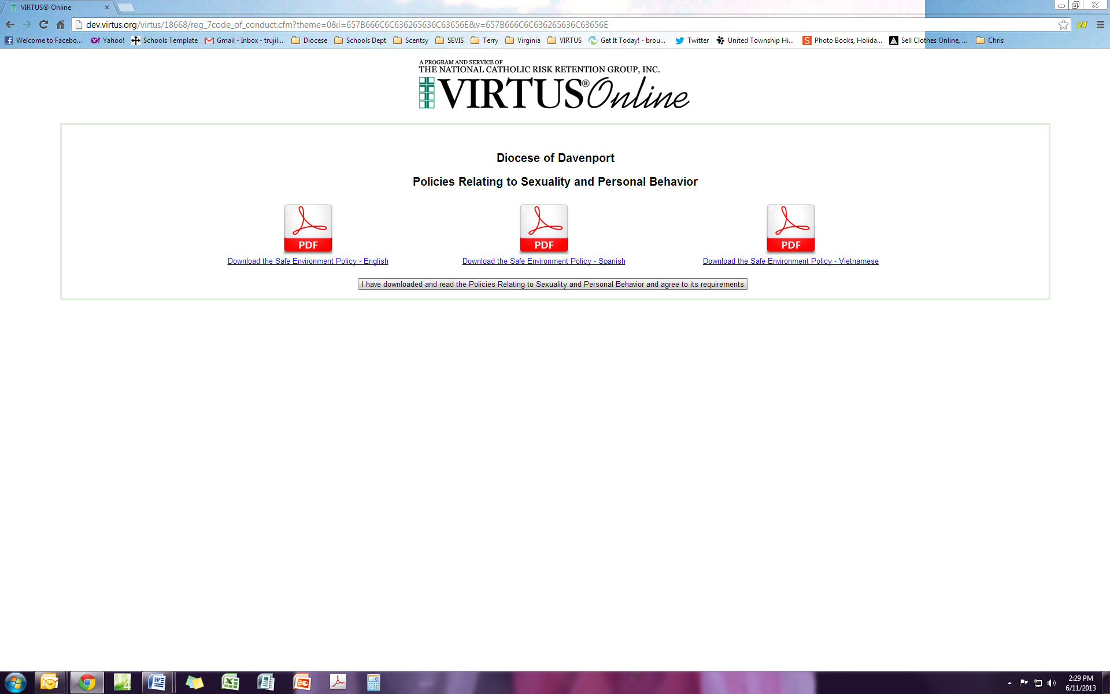
We are required to read the Diocesan policies and ensure you understand your responsibilities of working with children and vulnerable adults. This is available in three (3) languages. You can read this electronically or print it off and read it.

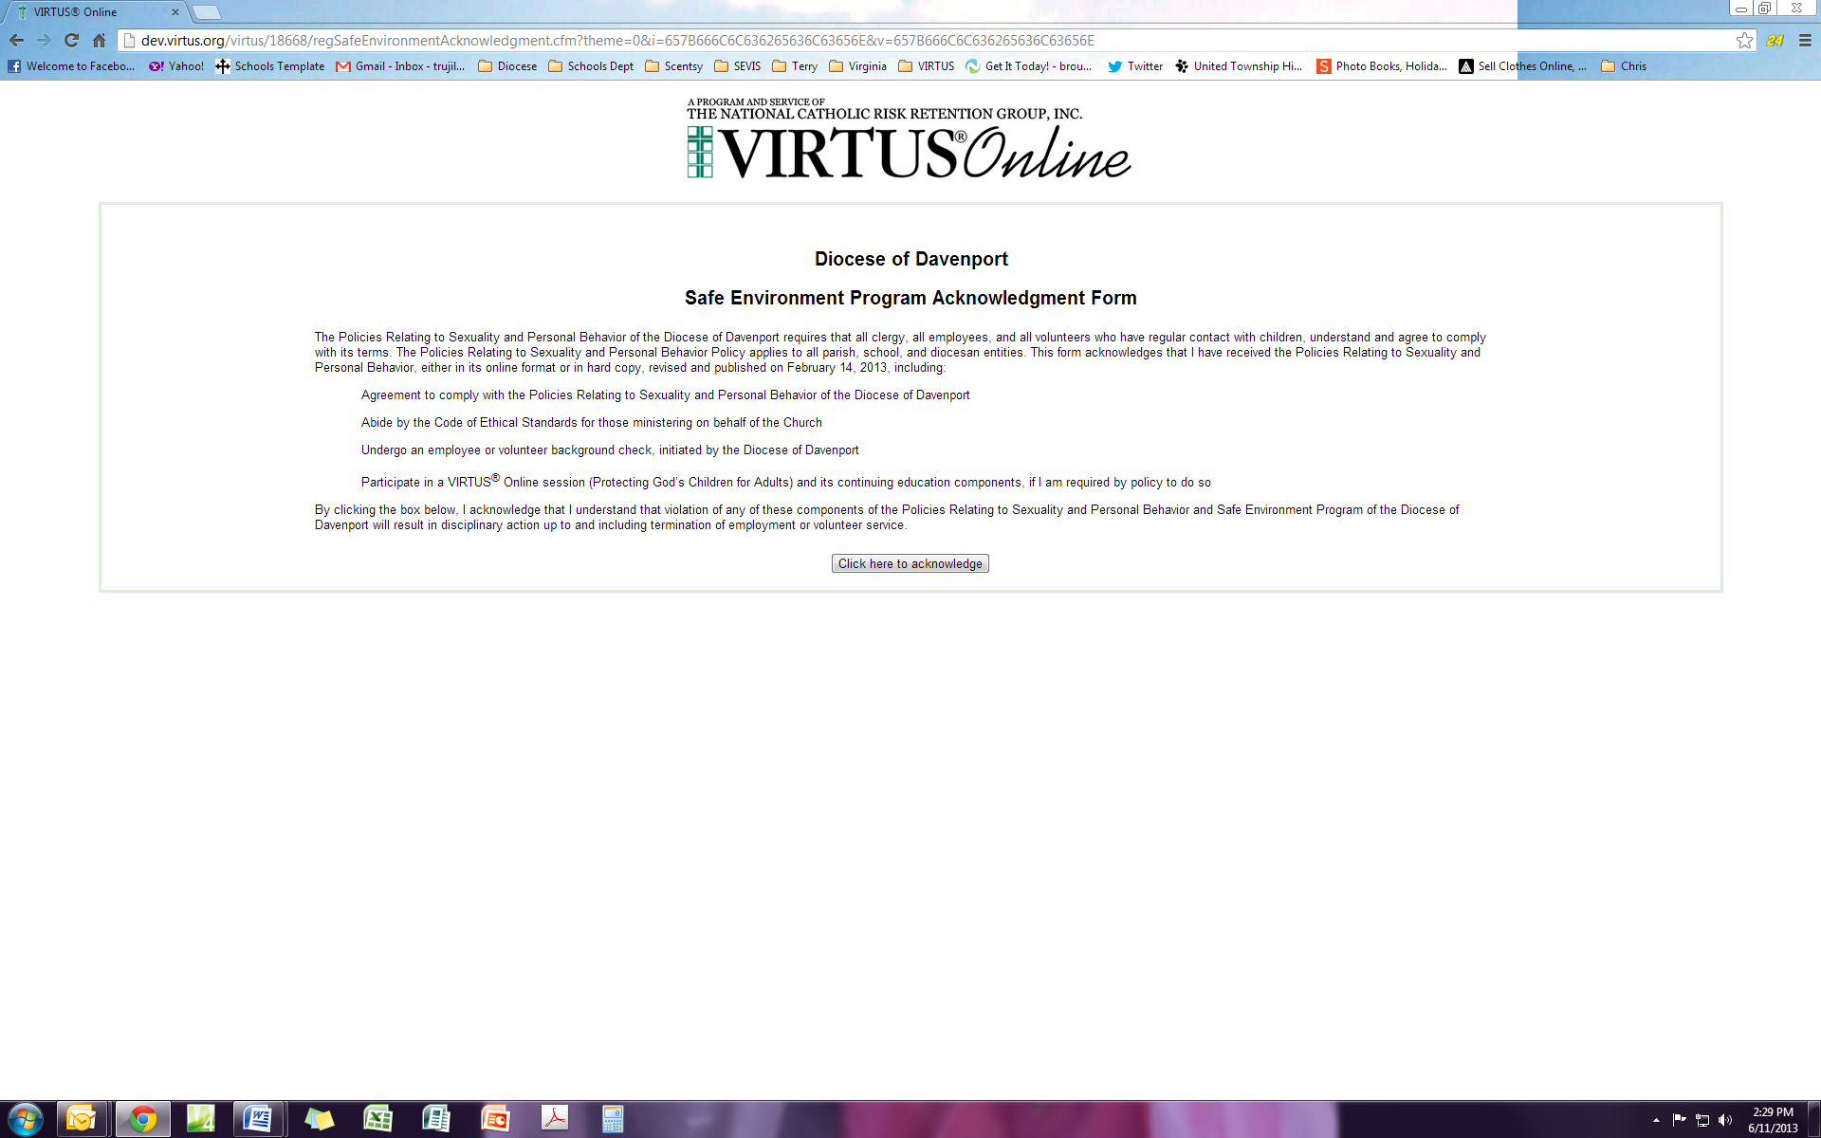
Clicking on the button you are acknowledging that you understand and will follow diocesan policies. This will be recorded on the “Training” tab of your VIRTUS account.

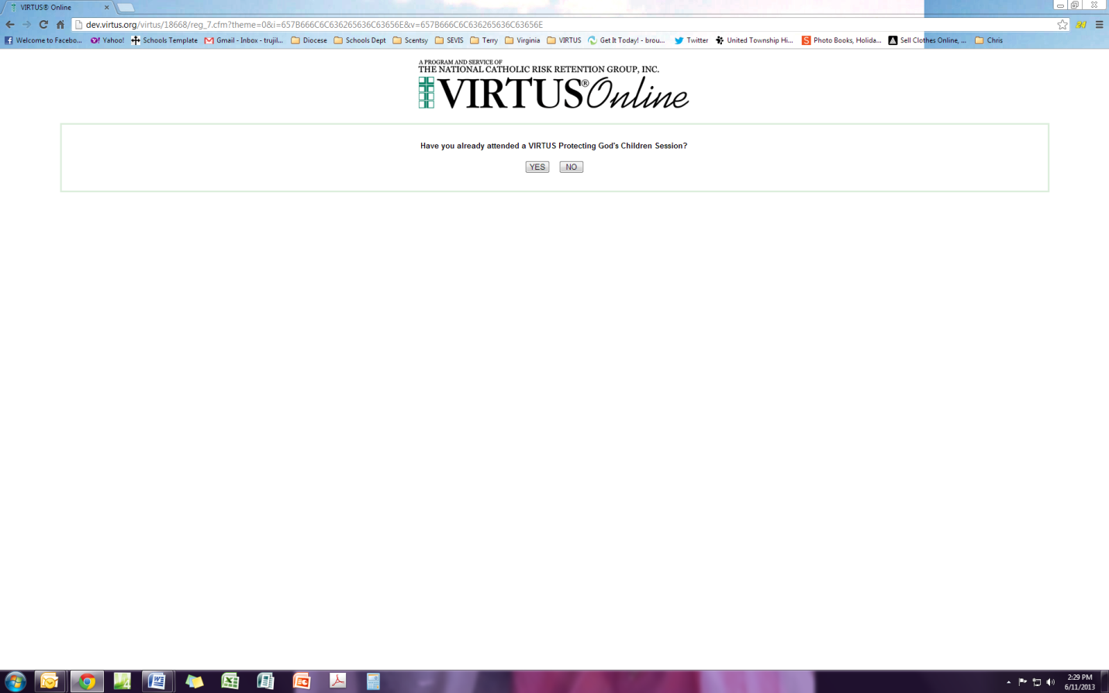
Answer No to this questions because it does not apply to the Diocese of Davenport

If you attended a “live” PGC training session between 2003-2011 DO NOT PROCEED, please X out. This may mean you are due for your 5 year PGC training renewal. Please contact your Local Administrator (SEC) at the school/parish on how to proceed.

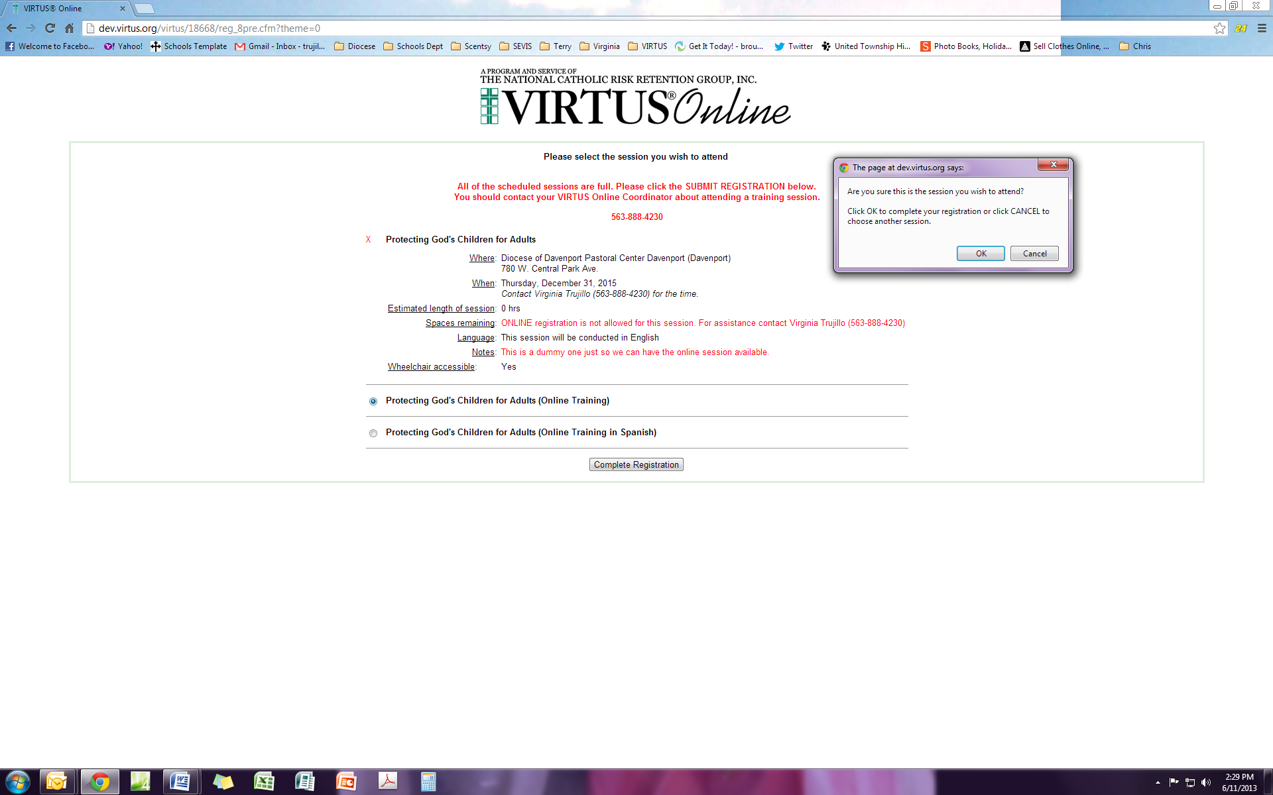
Choose the language in which you want to view the video. (You will need to view the video after you complete the background check (ESR) process. )

Click “Complete Registration”

You will then get the pop up box on the right and click “ok”

2
3
1

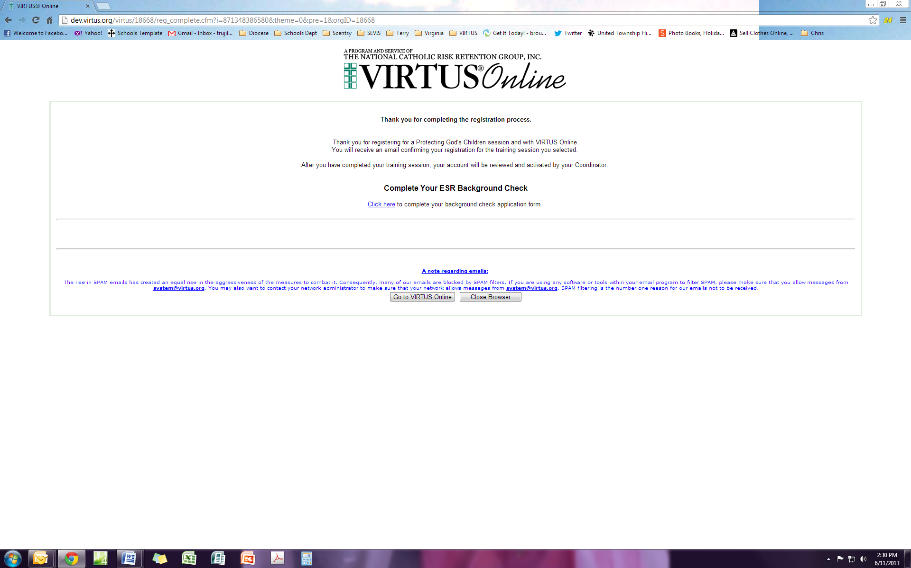
You will now need to complete your background check through the ESR website. You need to “click here” to be directed to the ESR website. It is highly recommended that you continue to the next step. This needs to be edited after we find out what VIRTUS and ESR says about shut down or leaving site.

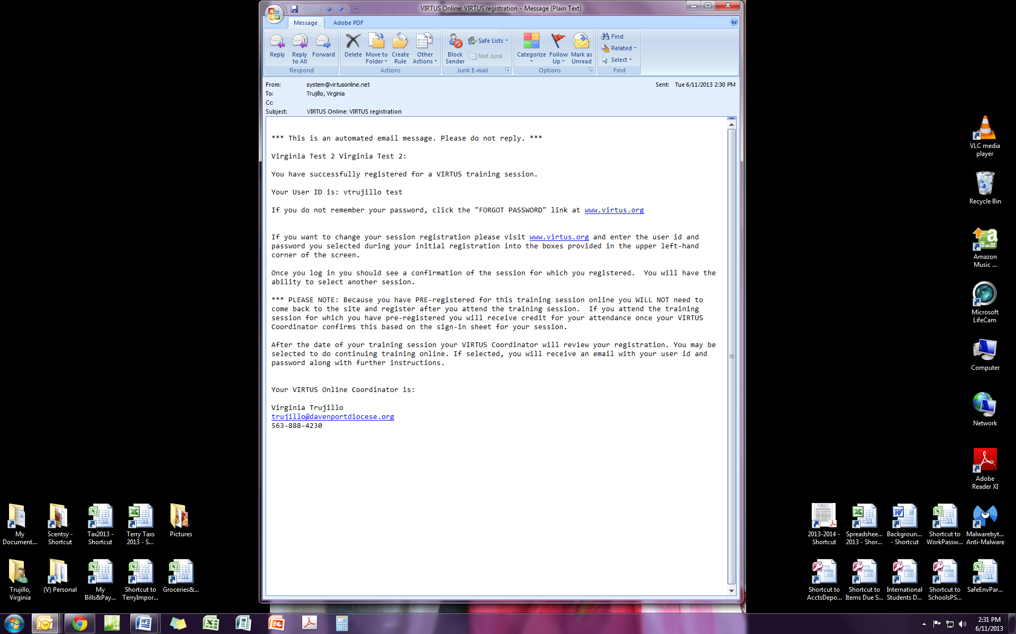
This is the email you will receive from VIRTUS letting you know that you have registered and also give you the user id and password you set up.

Step 2: ESR website for Background Checks

This website is compatible with all major browsers in the following versions.

Browser | IE | Firefox | Chrome | Safari | Opera
Version | 9.0 and above | 17.0 and above | 23.0 and above | 5.1 and above | 12.0 and above

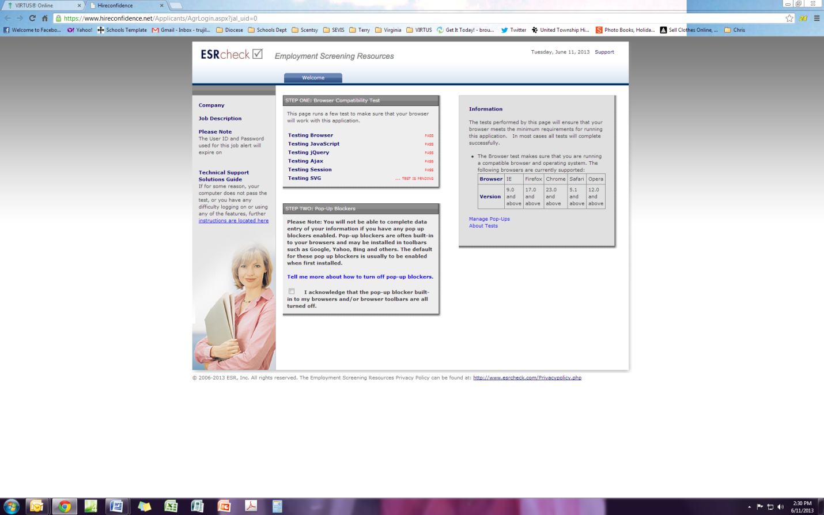
The ESR system will run a test on your computer to ensure you can complete the BGC with your version of software. If you don’t meet the requirements you can use a school/parish computer or any public computer to complete this.
You will need to check the pop up acknowledgement box and then you will get another screen asking you to sign with your mouse to make sure your computer accepts the browser.

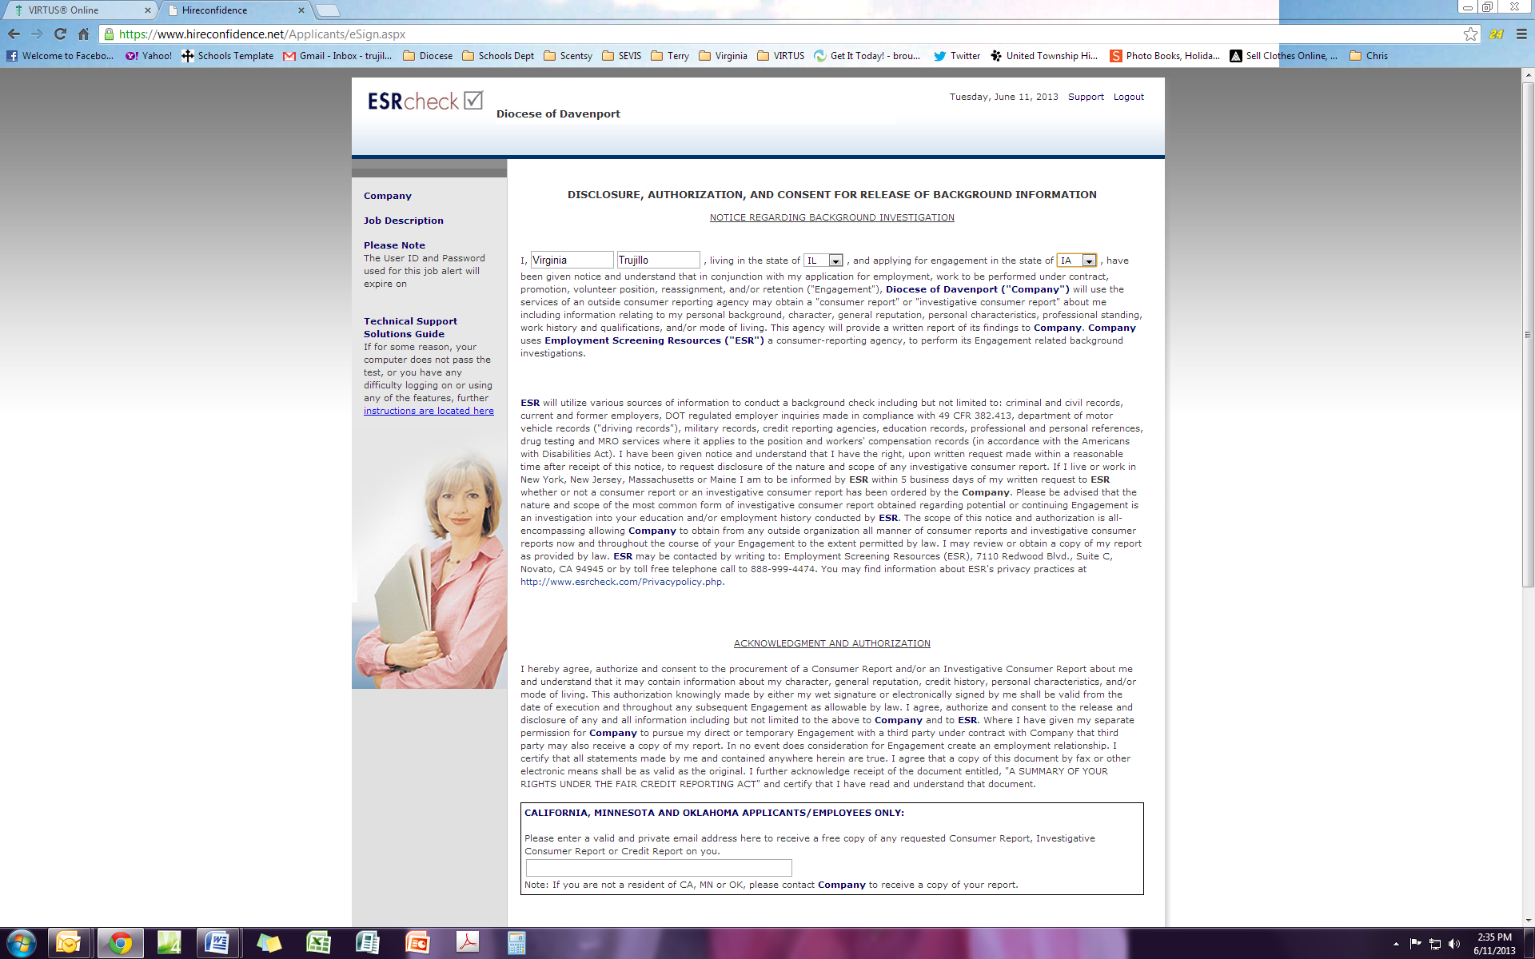
You must fill in the blank boxes , read on and scroll down to complete more questions.

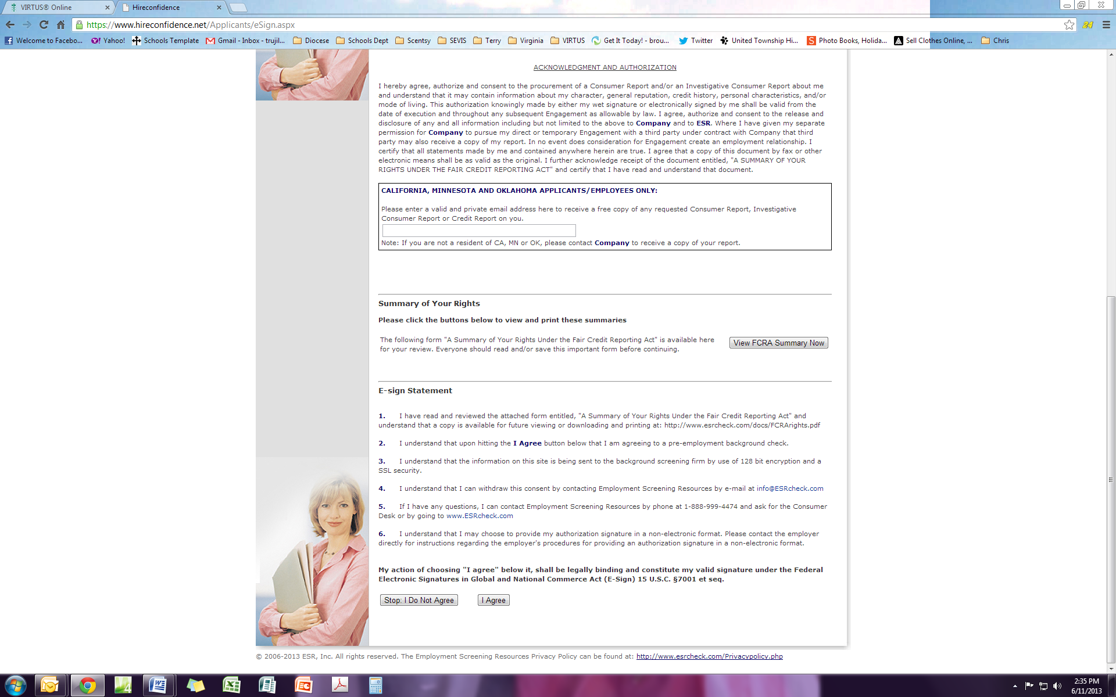
You will need to click I Agree to continue
Click to view FCRA (Fair Credit Reporting Act) summary.

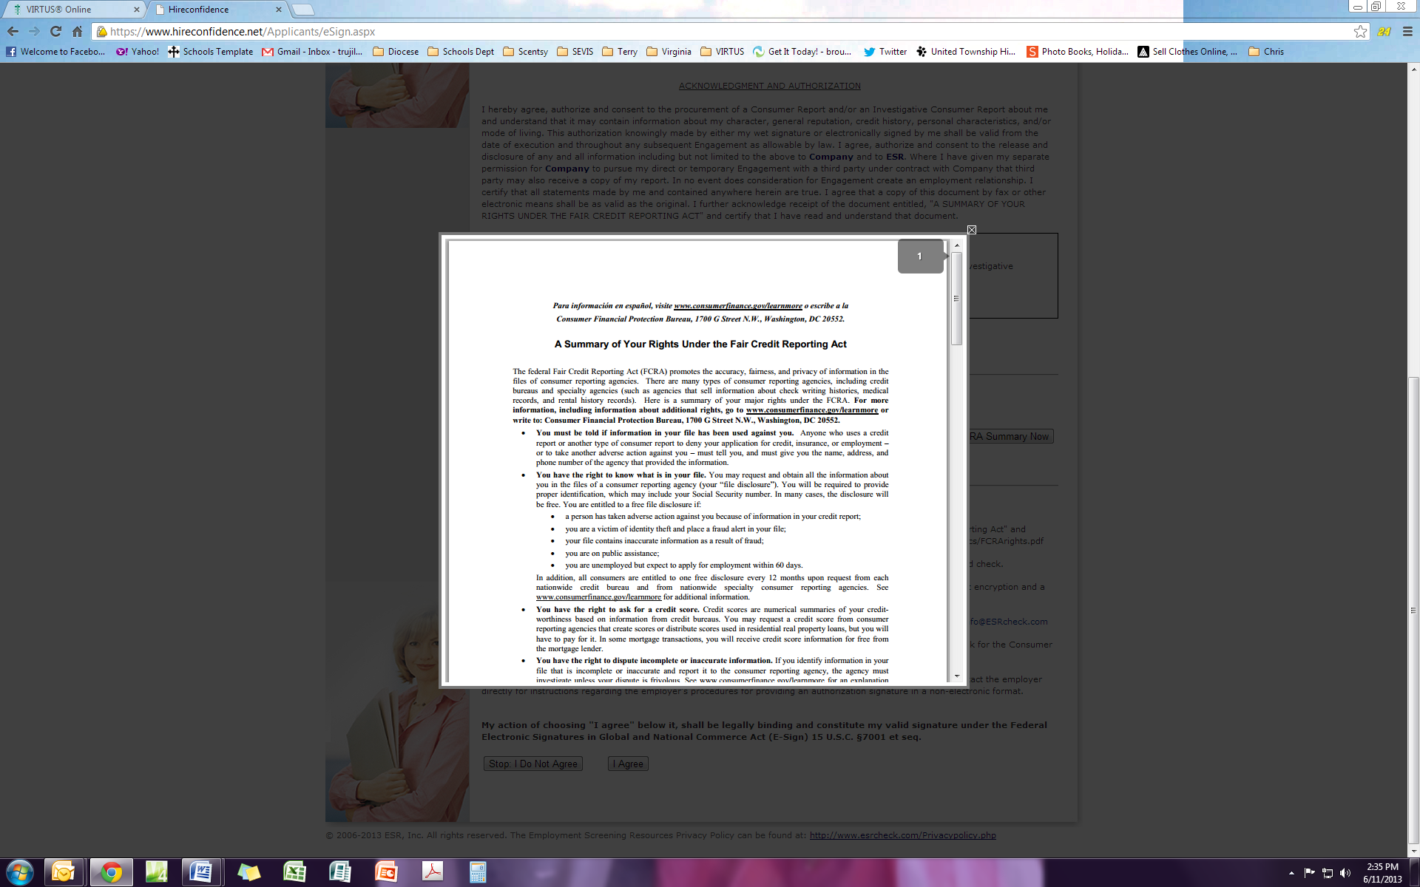
When viewing the FCRA (Fair Credit Reporting Act) Summary this is what you will see.

After agreeing to the above you will see the yellow box

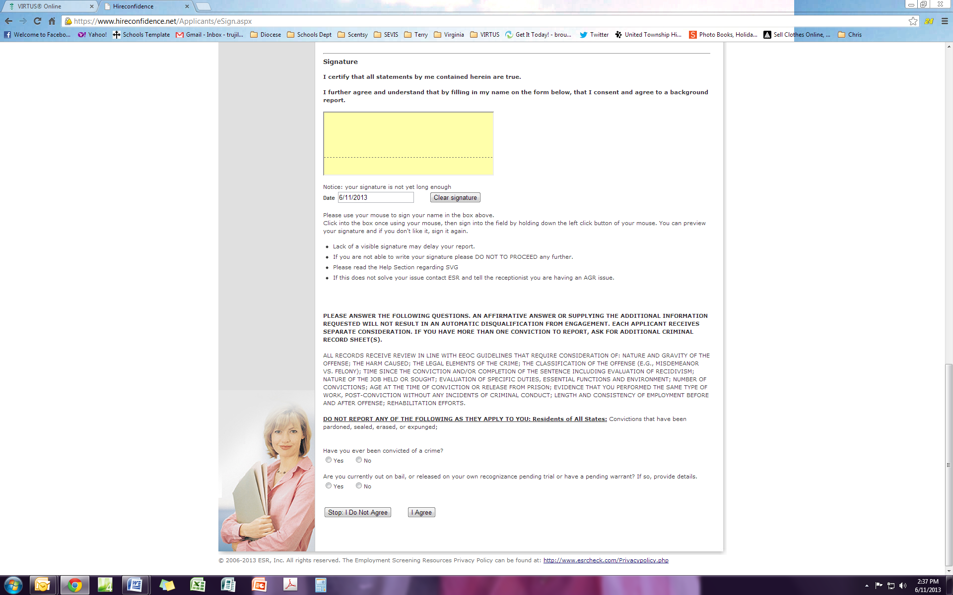
Click yes or no to criminal history questions
Sign here with your mouse

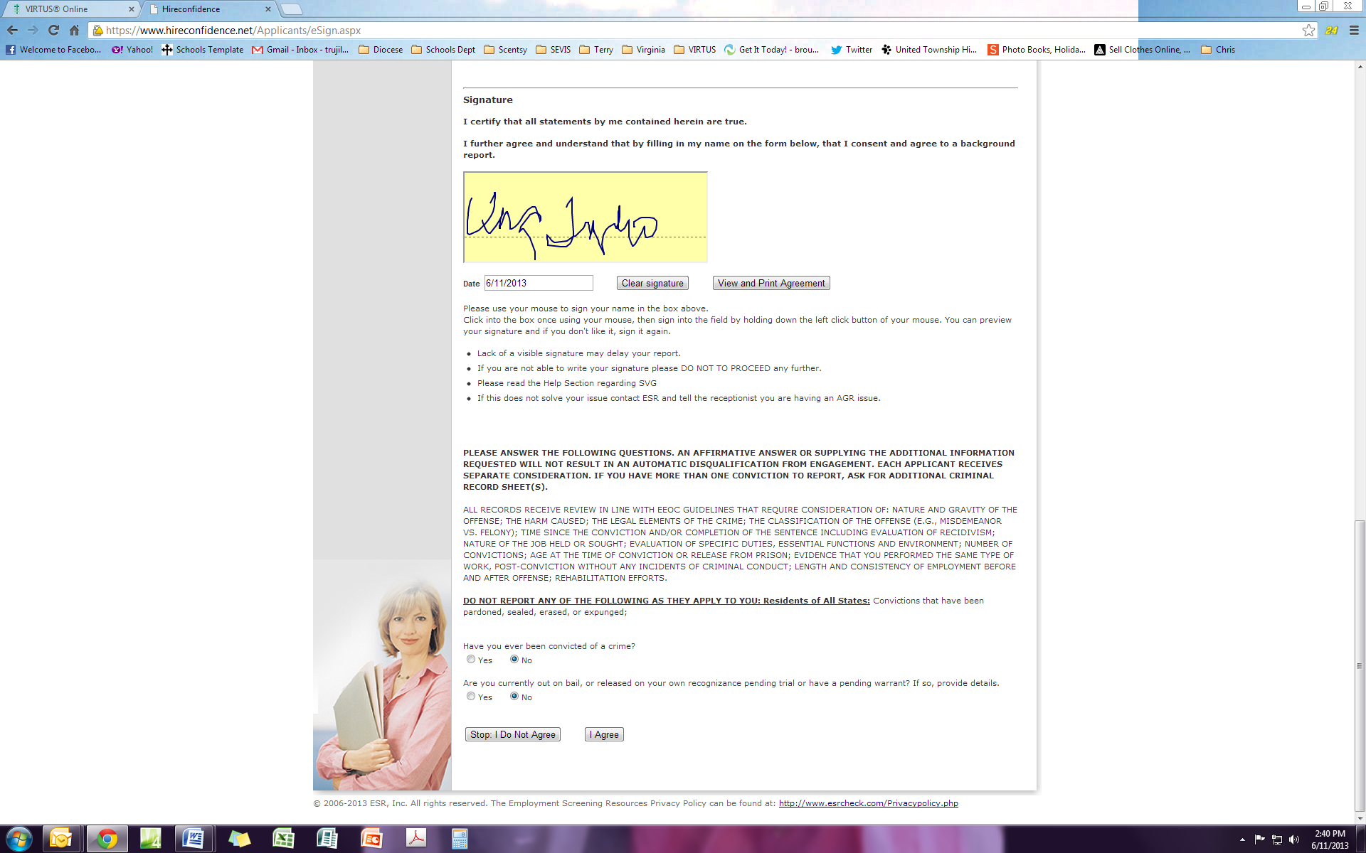

What your screen should look like when you have it completed.

If you choose to Print Agreement you will see this. If you choose not to, you will go to the bottom of the page and answer the rest of the questions.

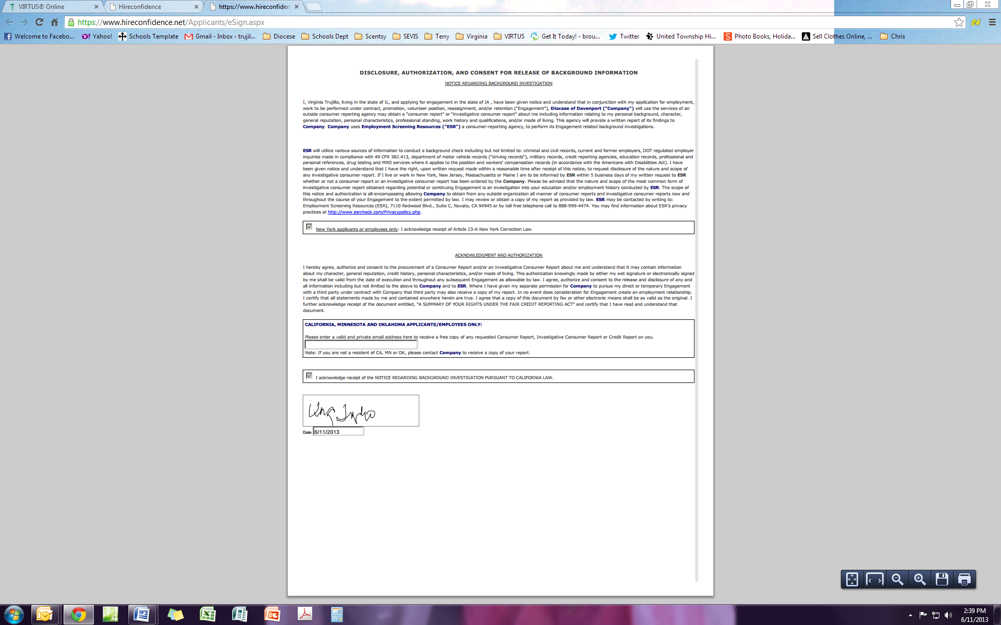
You have a time limit or you will be removed from the site.

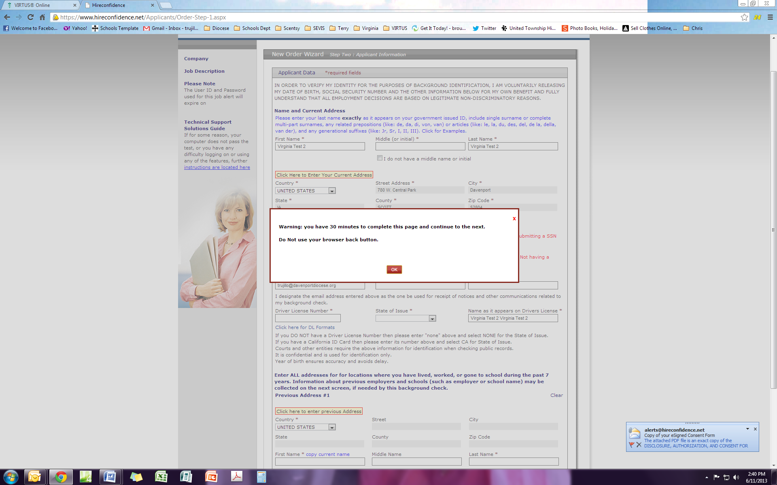
This will pop up on your screen to let you know there is a time limit

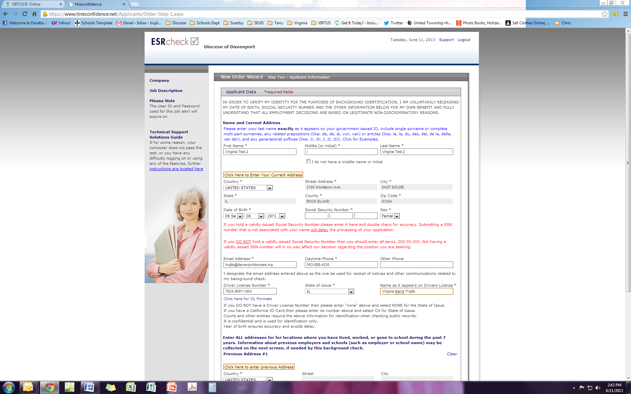
This is where you will fill in your personal information. Note: Some information may have come over from the VIRTUS website to already fill in fields. Review it and edit anything that is incorrect.

Undocumented volunteers or employees that don’t have SS# can enter 000-00-0000

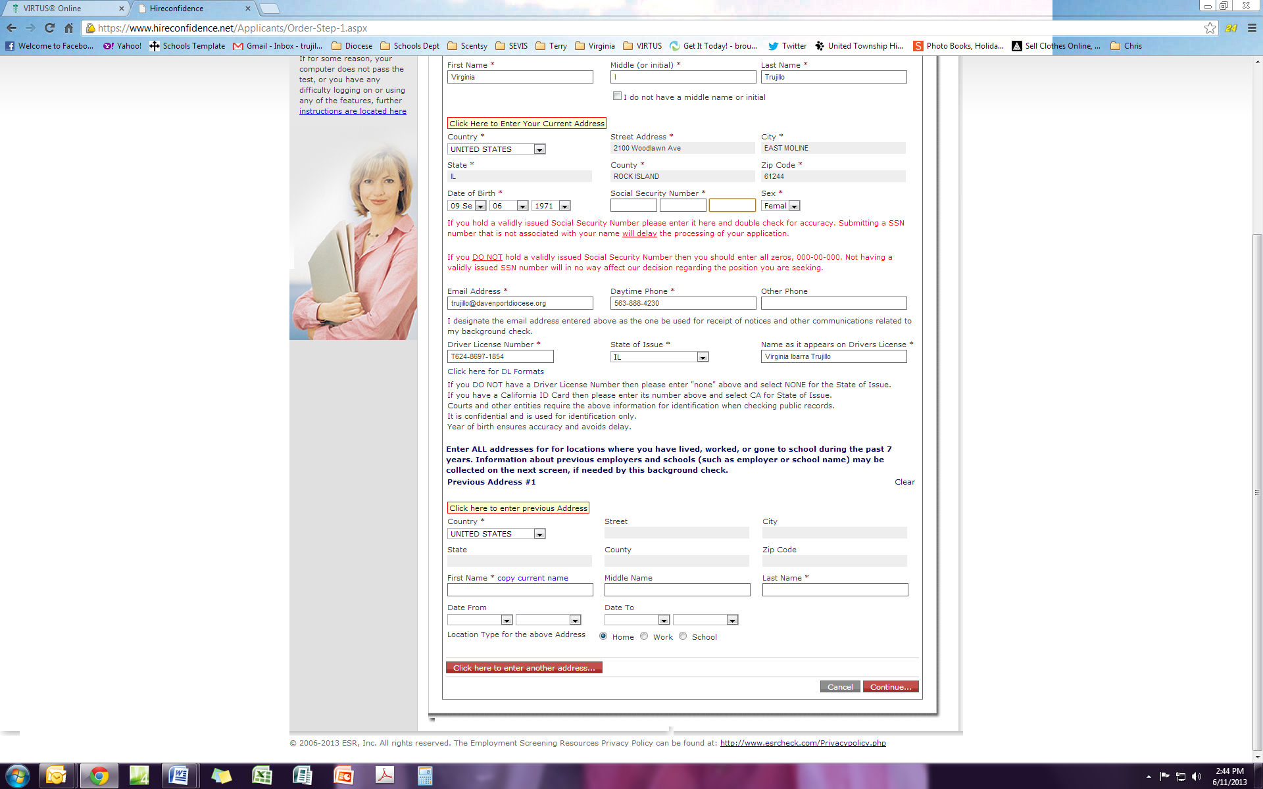
Click on Continue

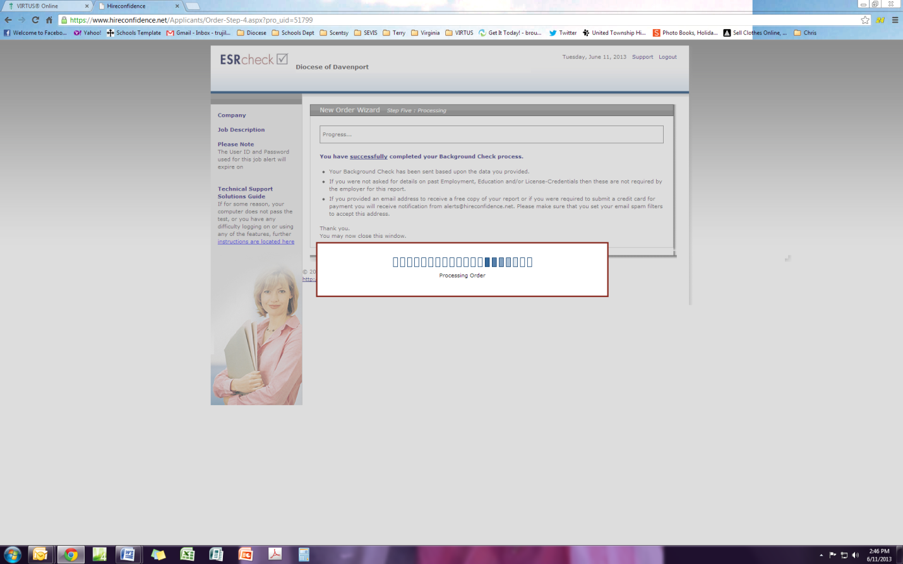
Processing screen

This screen shows you have completed the BGC successfully. Your information will be recorded in the VIRTUS database with the date you completed this process. If there is a criminal offense or child or dependent adult abuse violation, this information will be sent to the Diocese and the proper school/parish personnel will be informed.

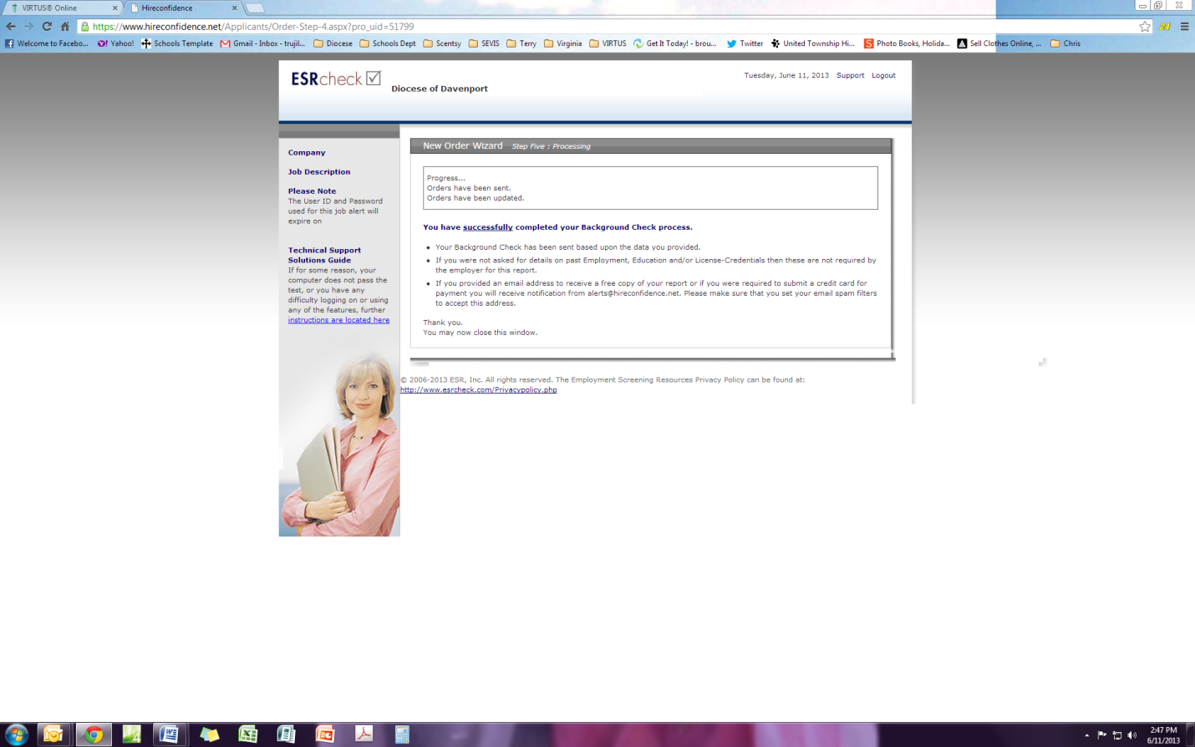

This is an email you will receive about the agreements.

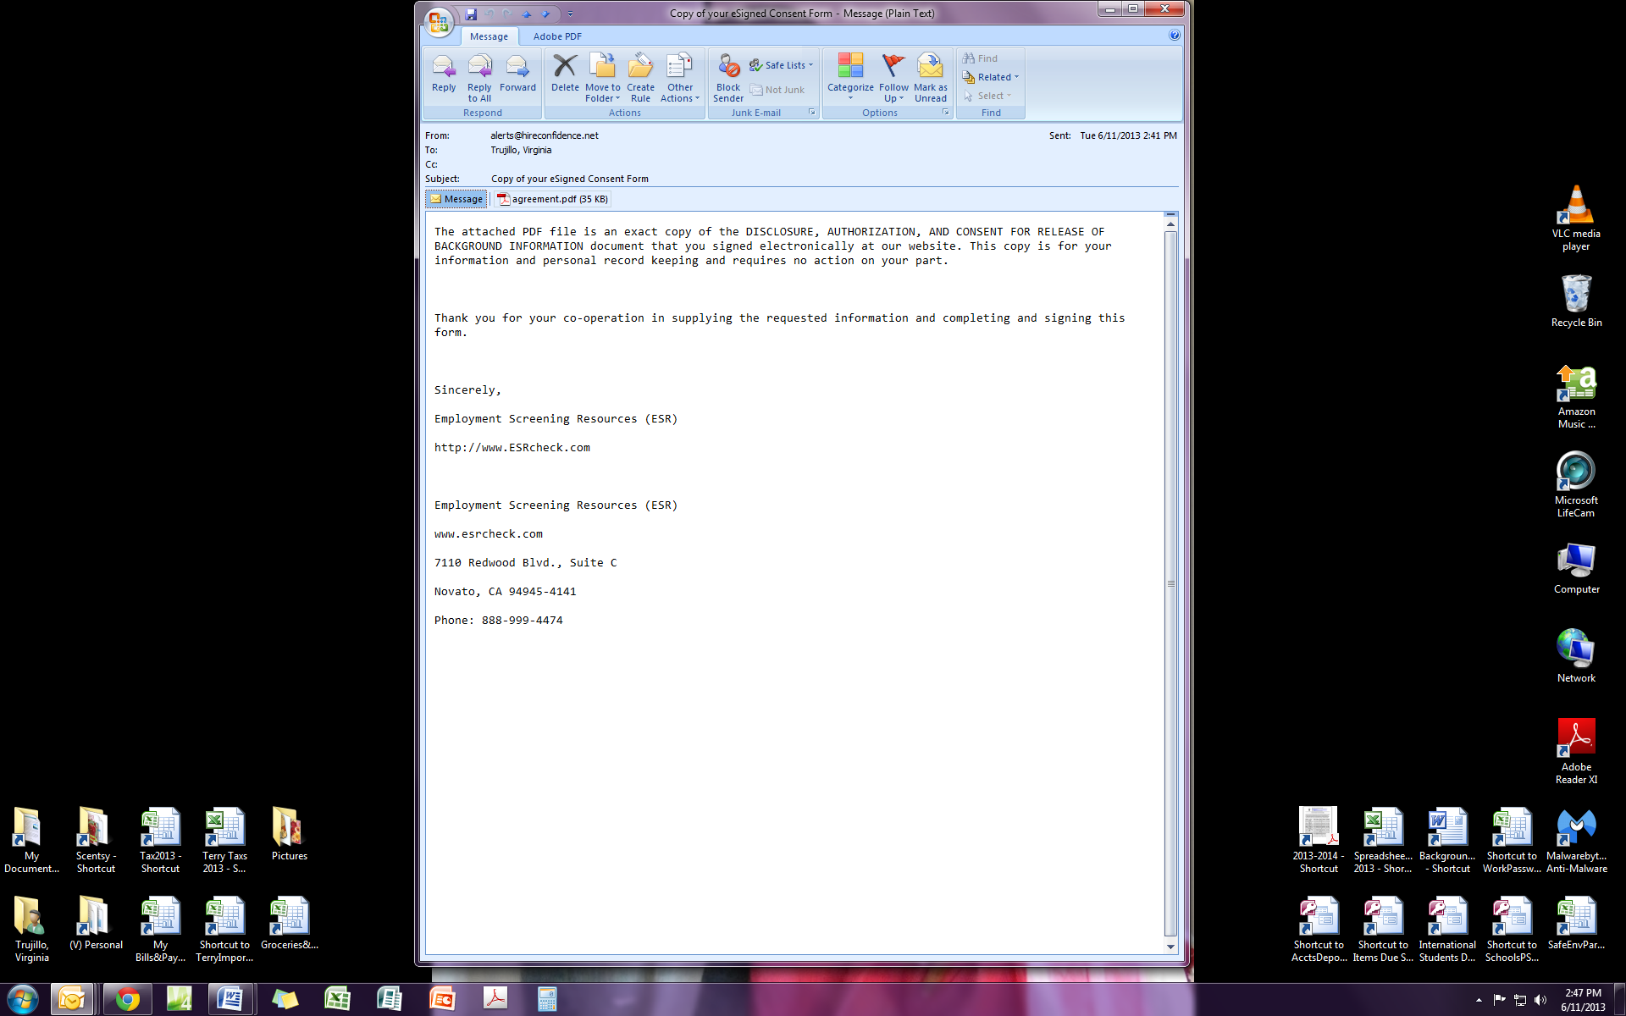

Step 3: Viewing “Protecting God’s Children” training video via www.virtus.org (90 minute video)

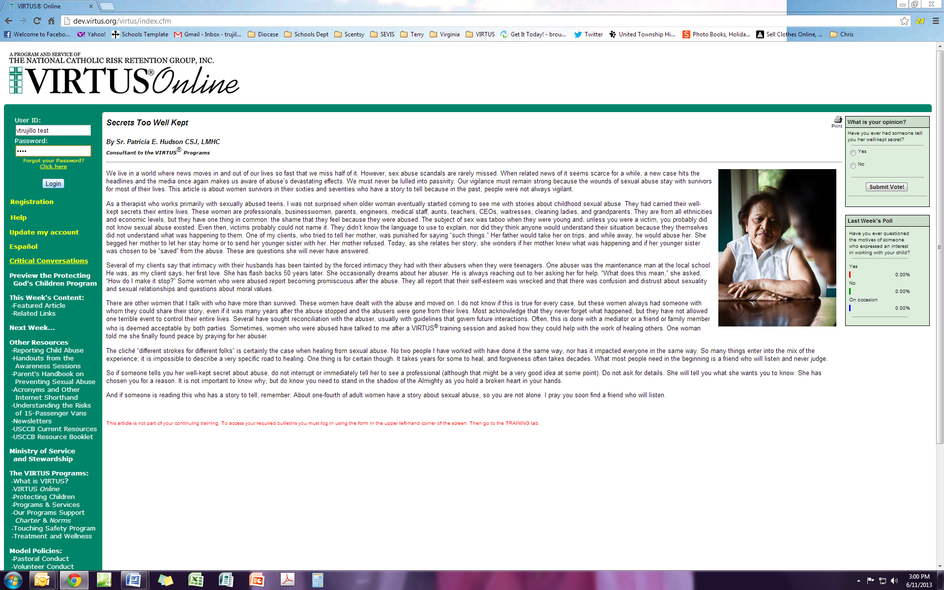
Put in your user id and password you just set up and click on Login

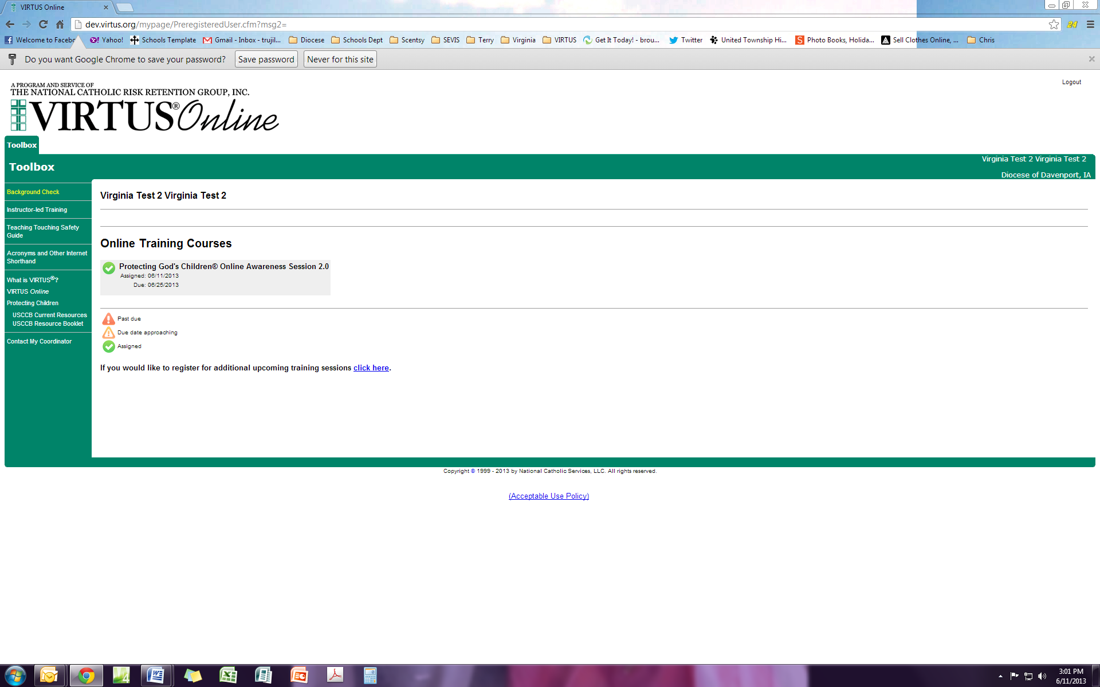
This will be the screen you see next. You need to click on the title “Protecting God’s Children Awareness Session 2.0”

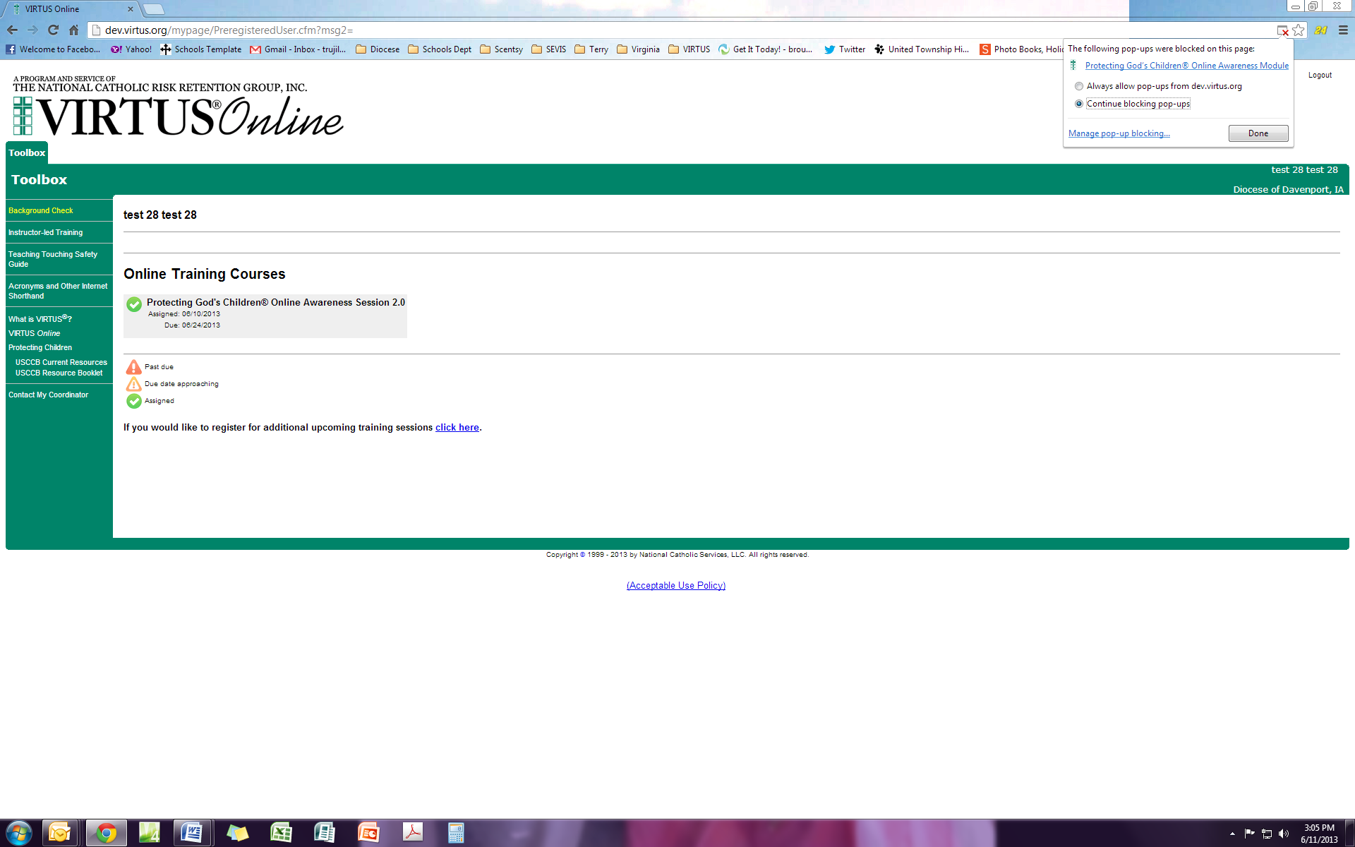
If your video does not start you may get a pop up blocker notice similar to the one above.

You need to allow pop ups in order to view the video.

The video will start and it has 290 slides and takes approximately 90 minutes depending on your internet connection.

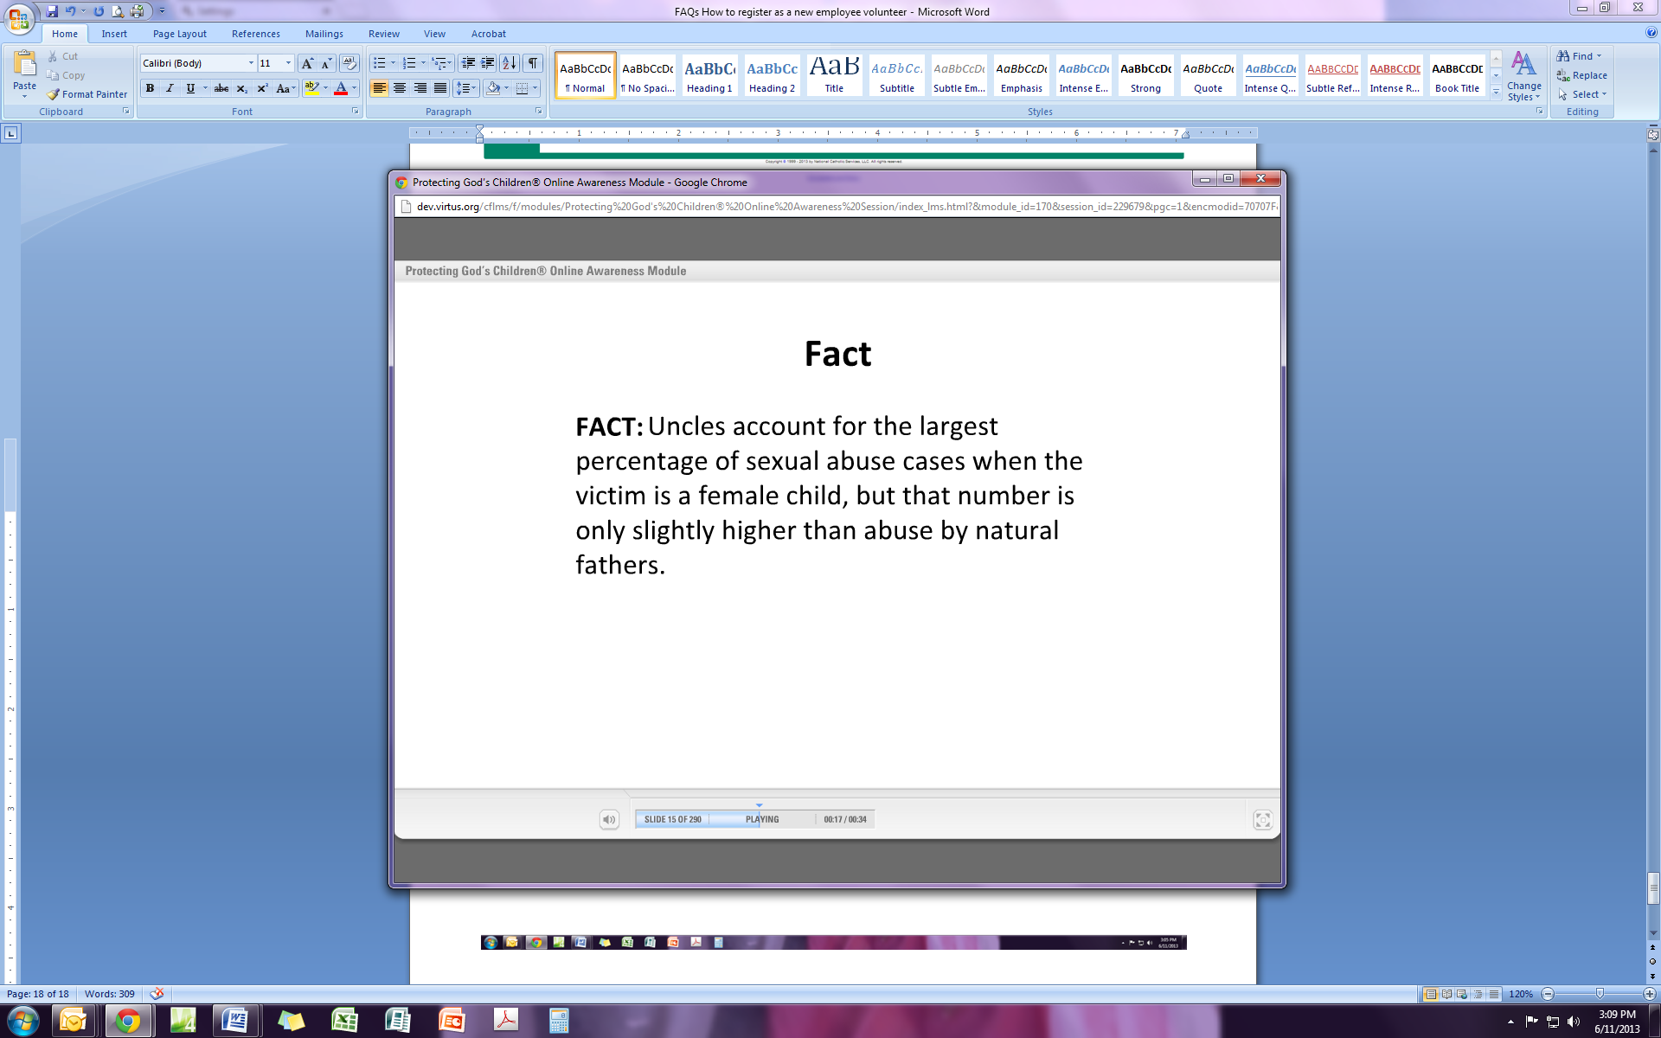
If you cannot finish all the video in the allowed time, you can close it (no pause button) and can log back into www.VIRTUS.org later. You will then be asked “Do you want to pick up where you left off?” and you would click “yes”. It will take you to the slide where you left off.

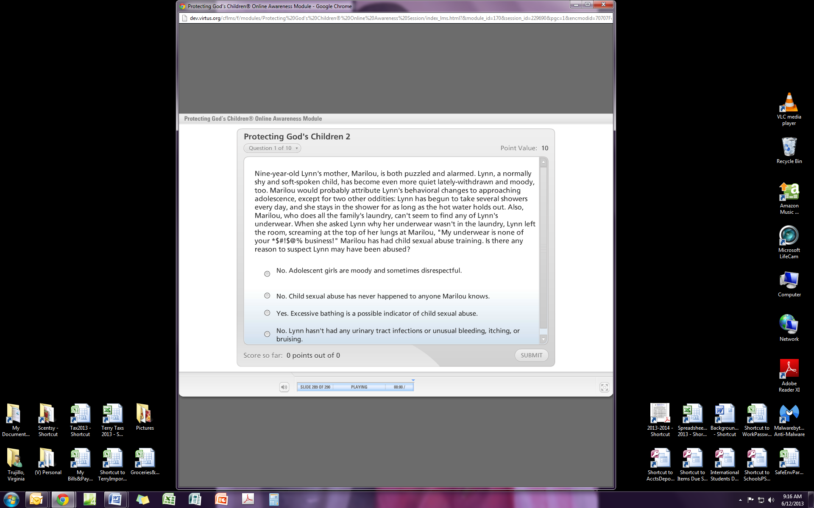
When the video slides are finished you will have 10 questions to answer.

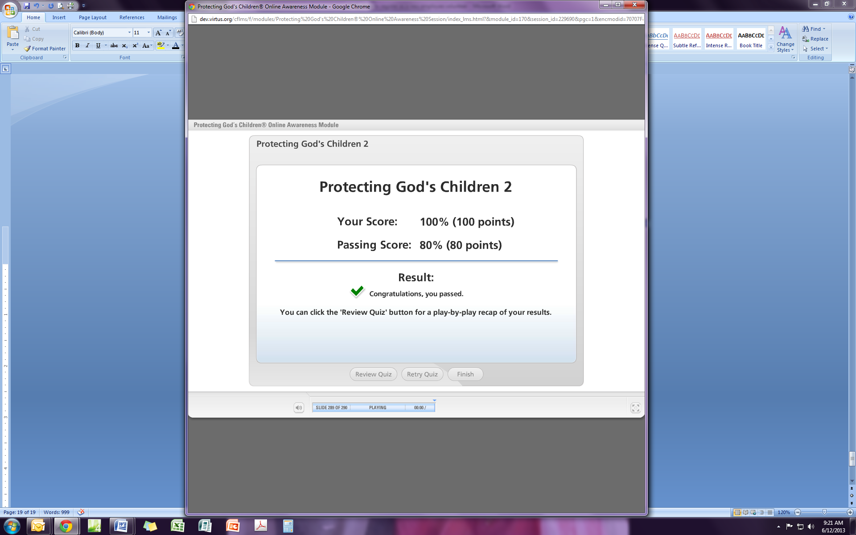
Screen showing you completed the training. Do not X out until the blue bar is all the way to the right or you will not get credit for training.

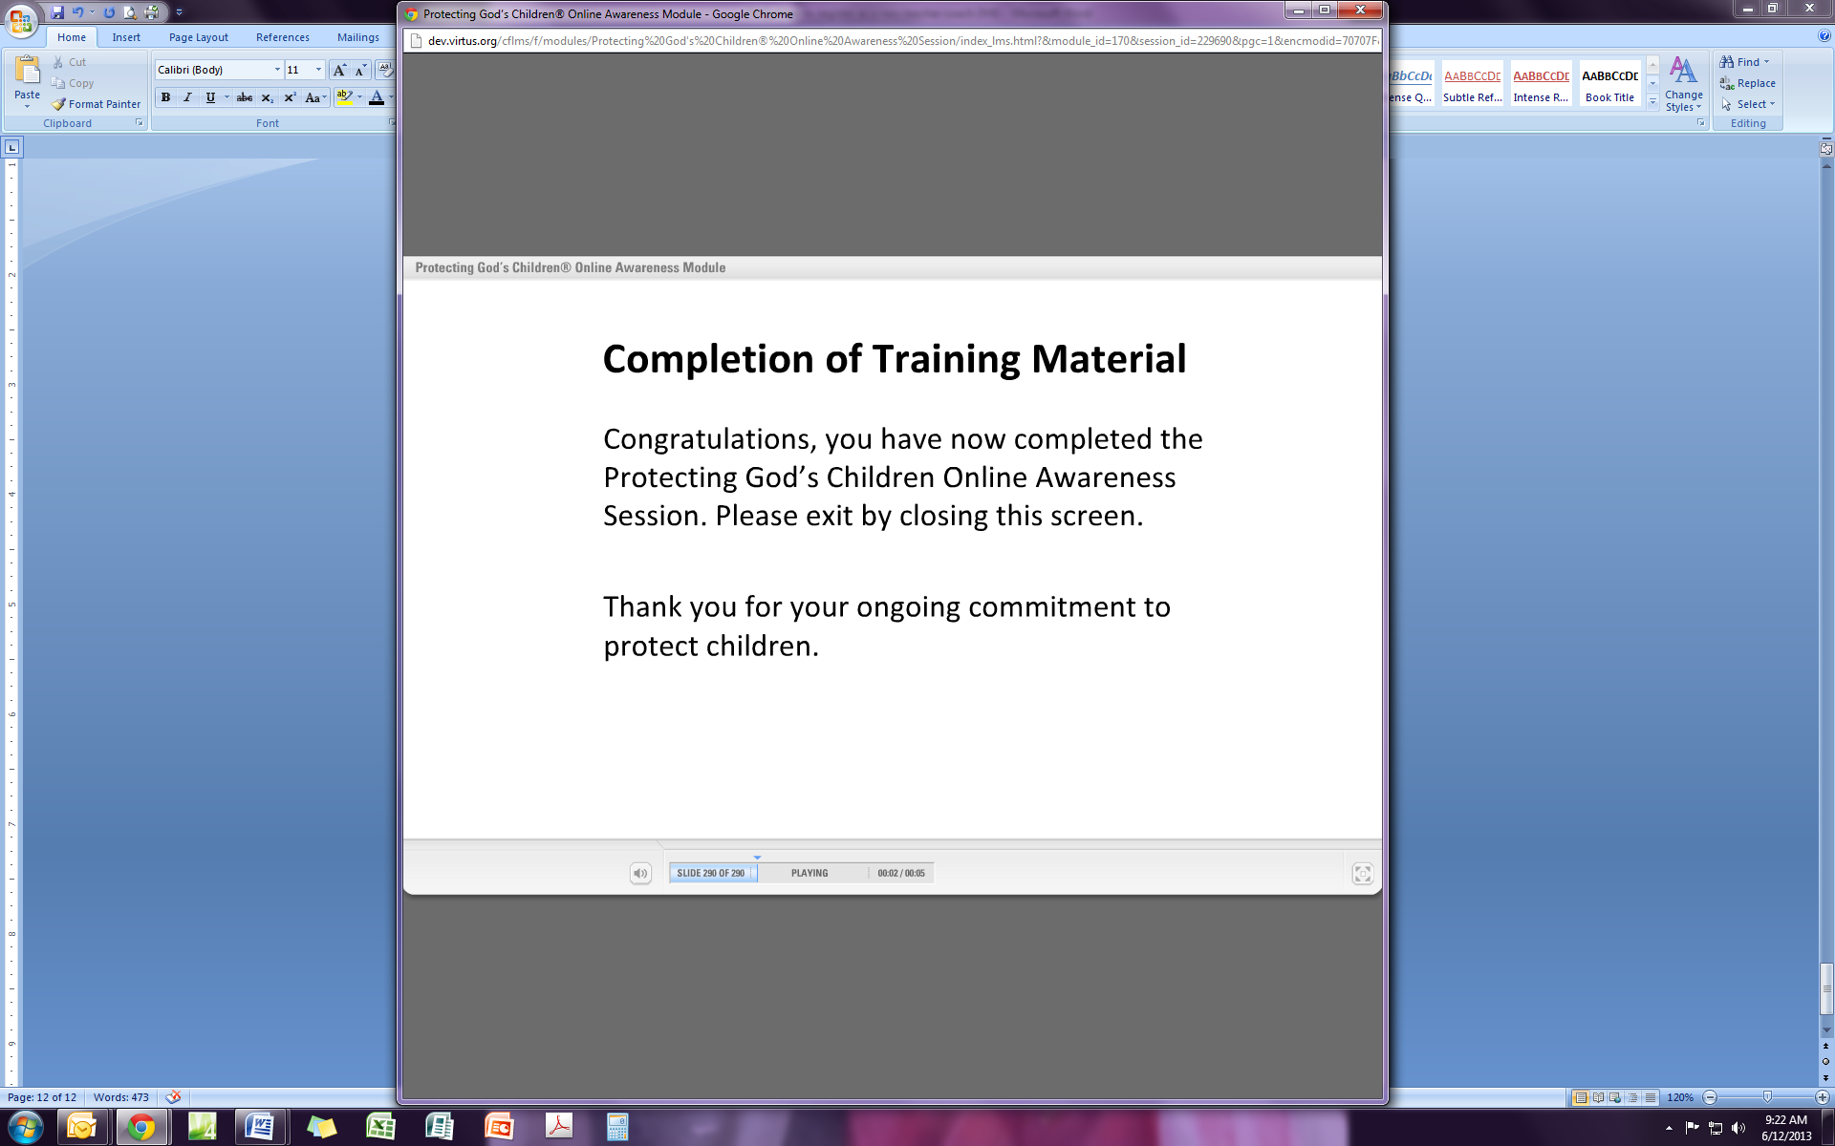
Screen showing you completed the training, do not X out until the blue bar is all the way to the right or you will not get credit for training.

Saving Data will cross your screen quickly and you will see this
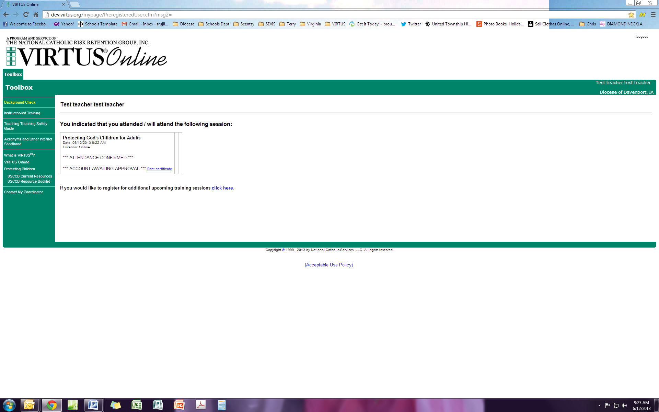
Do this first: You will click here to print your completion certificate which is a PDF document.

2nd: Logout

Print a copy for the local administrator (SEC) at your school/parish and save to your computer for future reference.

